

User Manual
For

Computerized Maintenance Management System (CMMS) – Hospital Staff

SMCI/SOP/002

DOCUMENT CONTROL

GENERAL INFORMATION

Document Name | : | User Manual for Computerized Maintenance System (CMMS) - Maintenance.
Intended To | : | Sunway Medical Centre Ipoh
Prepared By | : | Tamimi Hasbi
Creation Date | : | 1st July 2025
Revision | : | 1.0

DOCUMENT REVISION HISTORY
Revision  No | Revision  Date | By | Description of Changes
1.0 | 01/07/2026 | Tamimi Hasbi | User Manual for CMMS – Web Work

DOCUMENT CONTROL 2
GENERAL INFORMATION 2
Web Work Module 4
1 Create New Request by Location and Department 5
2 Dashboard 9
3 Cancelling Request 10
4 Monitor work order status 11
5 Acknowledge Request 12

Web Work Module

Create New Request by Location and Department

Open “http://10.9.1.34/webwork” this link on the web browser (Desktop / Mobile).
Username | <Window ID>
Password | <Password>

Insert login information:


1.2 Select

To Request by Department simply click Request by department

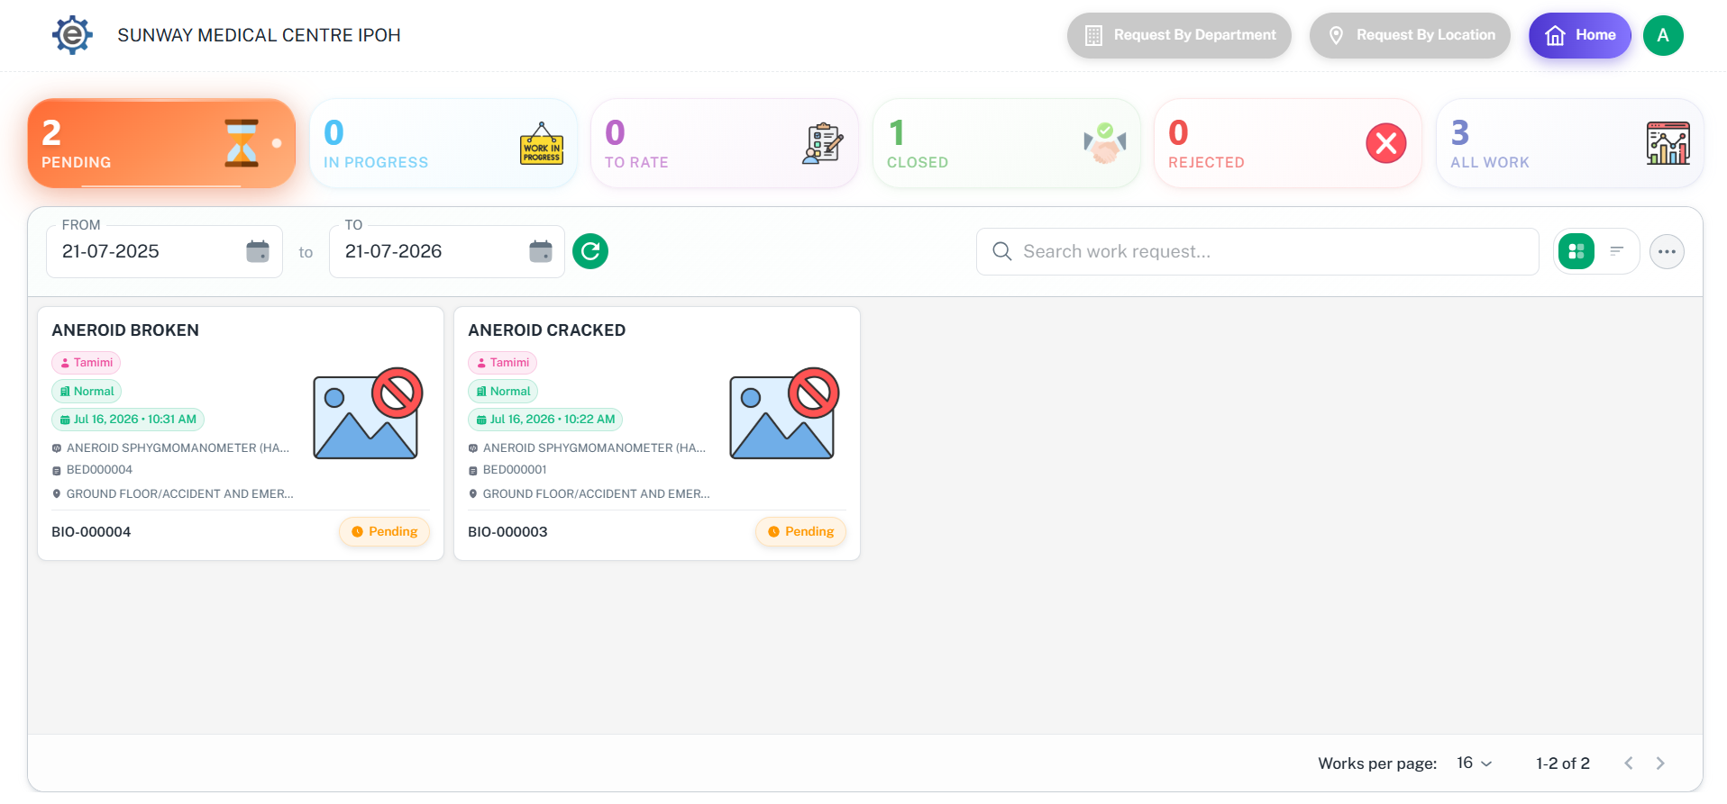
1.3 Click

Fill in all request information as per example below.

Contact No | [Phone No/Department No]
Requestor Name | Alimat
Services | Building Services
Department: | Accident And Emergency
Level: | Ground Floor
Asset Number | BSD000172
Fault Code: | Broken
Request Classification | Dirty
Request Description | Broken Fan. Please Fix. Thank you

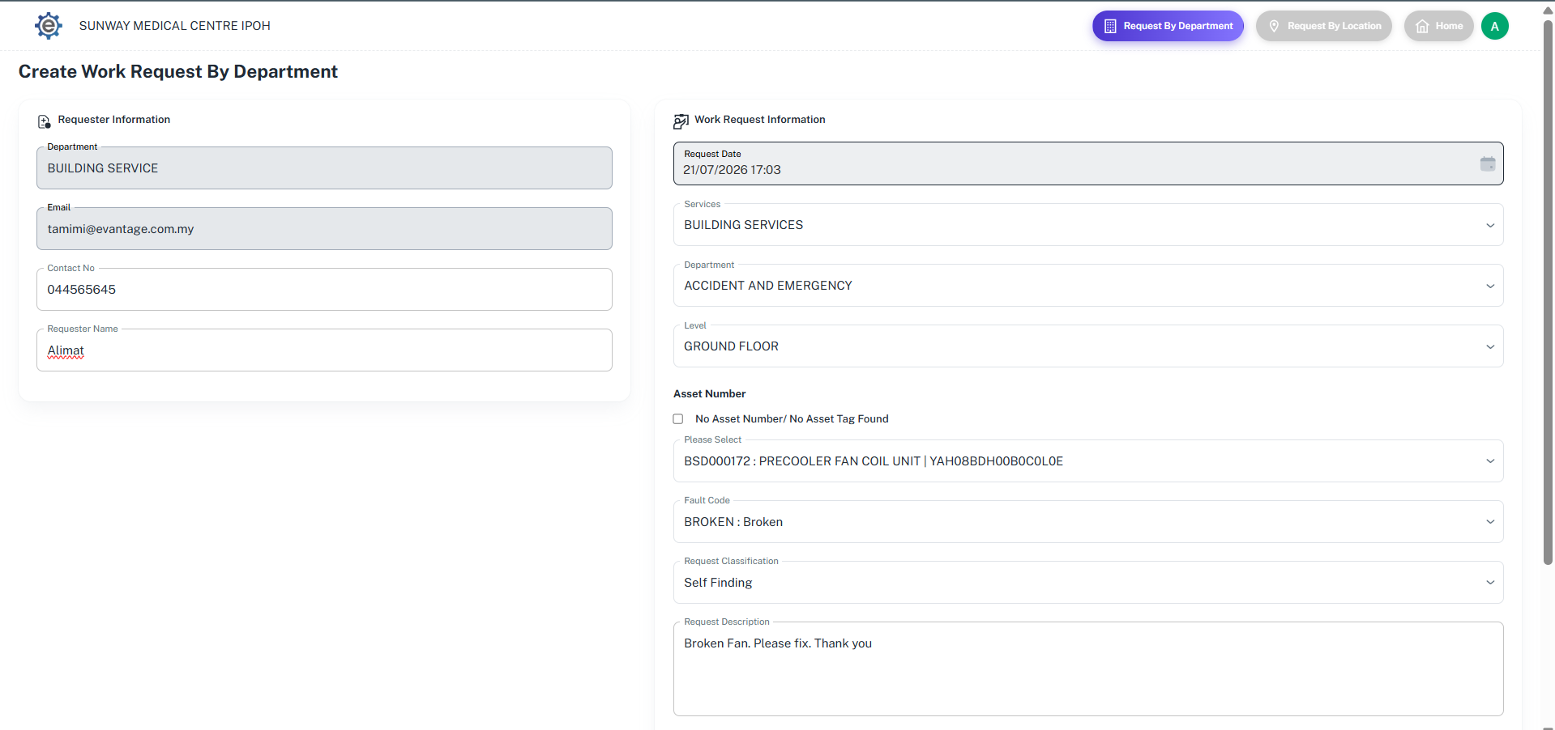
1.4 Fill in

Once all the required information has been filled in, click Save button. A Work Order Number will be generated, indicating that the work request has been successfully submitted. The requestor will also receive an email notification as a record for future reference.

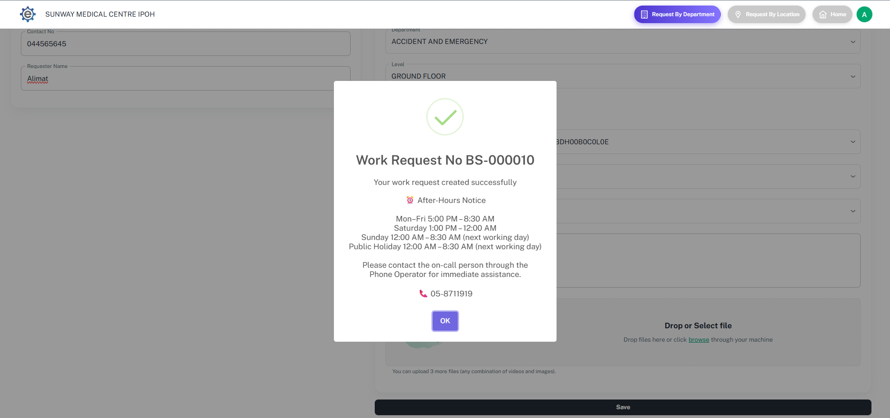

To Request by Location simply click Request by location.
1.6 Click

Fill in all request information as per example below. Tick no asset number to request asset without asset number.
Contact | [Phone No/Department No]
Requestor Name | Alex
Services: | BUILDING SERVICES
Level: | GROUND FLOOR
Room/Sub Area: | A&E-GF-01 | ACCIDENT & EMERGENCY | A&E GREEN ZONE AREA
Asset No: | BSD000034: PNEUMATIC TUBE | TRANSPONET
Fault Code | Dirty
Request Classification | Breakdown
Request Description | Tube Dirty, send someone to clean the tube

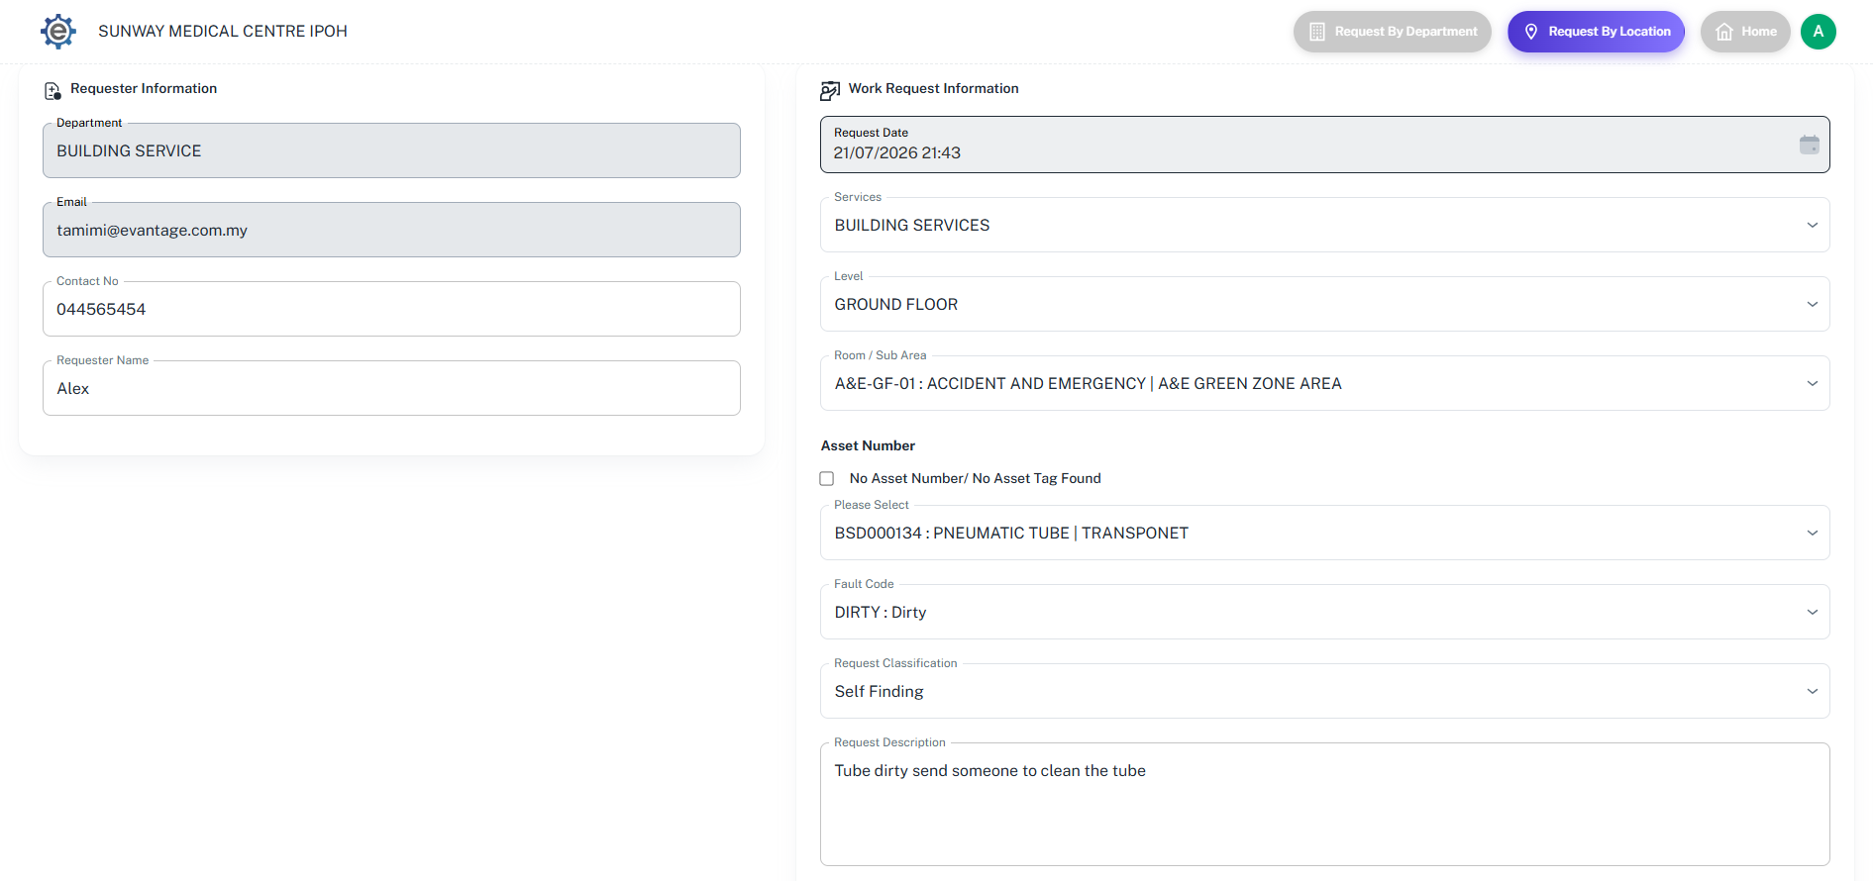
1.7 Fill in

Once all the required information has been filled in, click Save button. A Work Order Number will be generated, indicating that the work request has been successfully submitted. The requestor will also receive an email notification as a record for future reference.
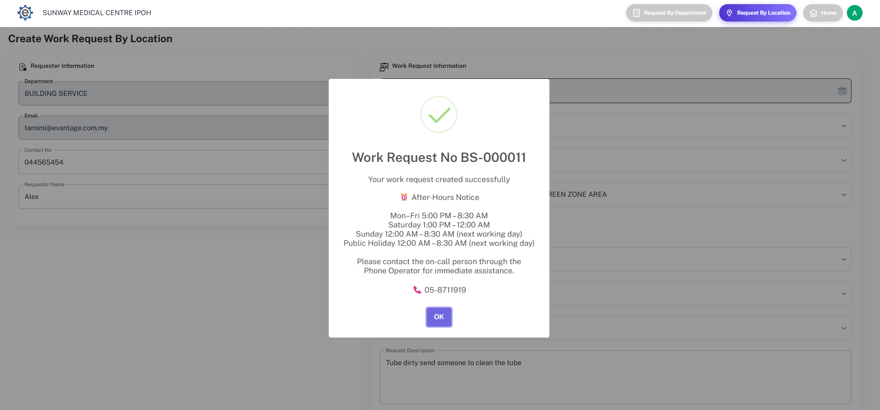

Dashboard
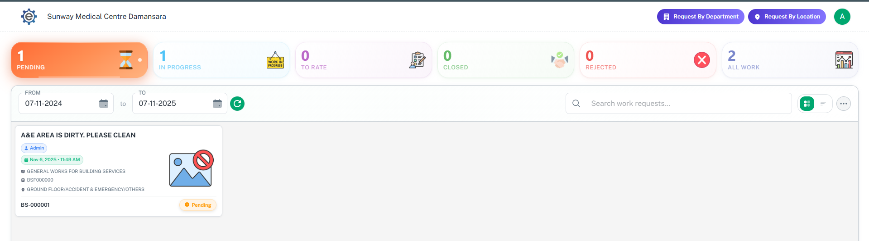
2.7
2.3
2.4
2.5
2.6
2.2
2.1

Date Setting: All the request are based on this date. Make sure you are selecting the right date.

Open Request: To monitor and canceling your request or department request.

In Progress Request: To monitor your work order status.

Acknowledge Request: To rate and acknowledge the maintenance work.

Closed Request: All the work that already finish or closed.

Rejected Request: All the request that has been rejected by maintenance.

All Request: All requests that has been issued by you or your department.

Cancelling Request

Click open request

Click work request that needs to be cancelled.

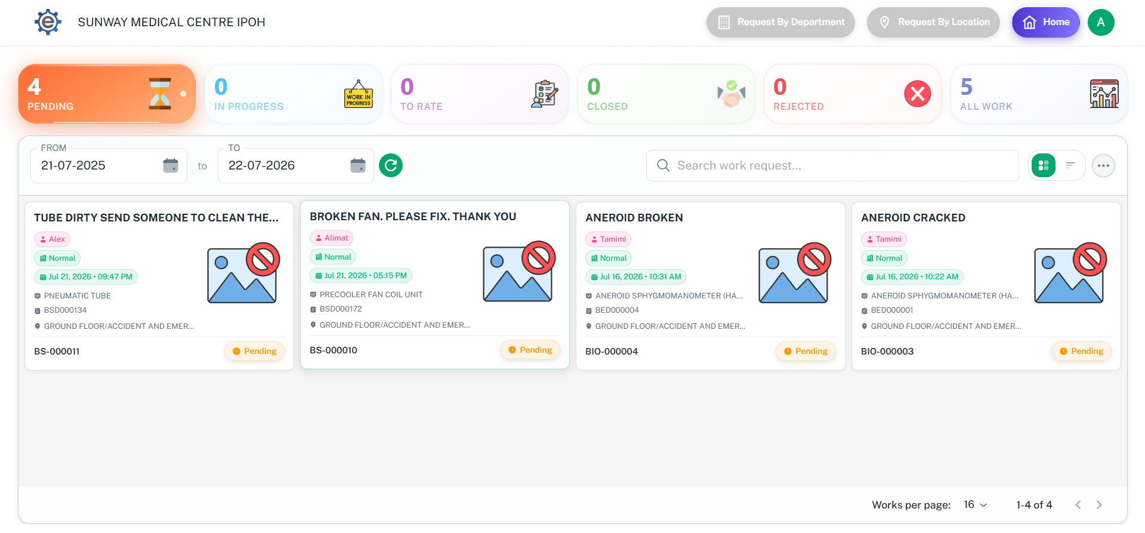
3.1 Click
3.2 Click Click

Scroll Scroll down and click “Cancel Work Request” to cancel the request

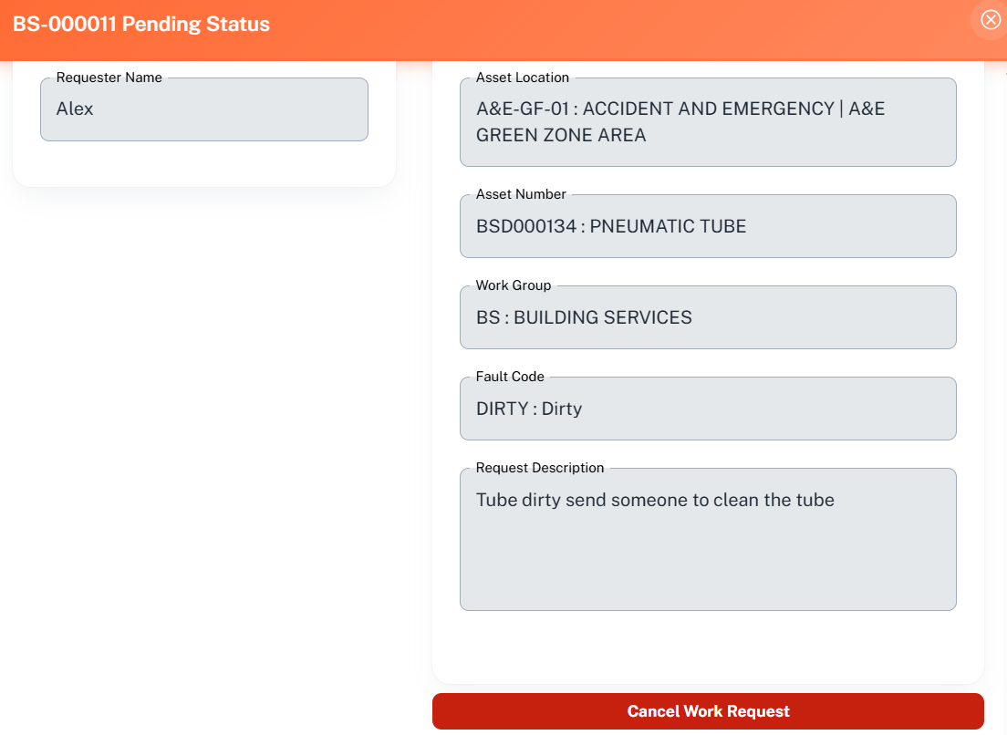
3.3 Click Click

Once you are cancelling the request, you need to provide the reason of cancellation.
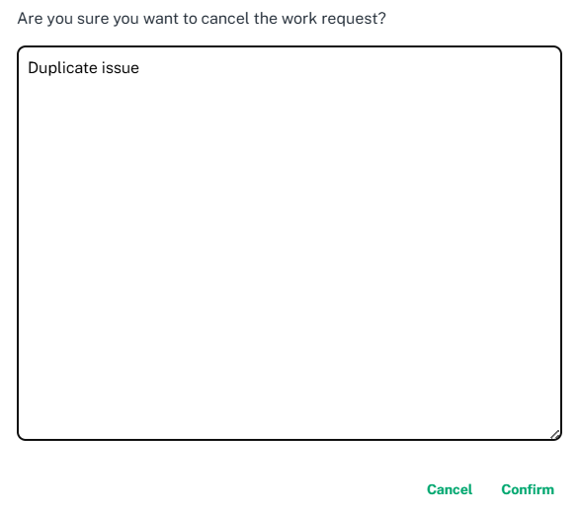

Monitor work order status

Click In Progress Request

On the right column, you can check your work order status

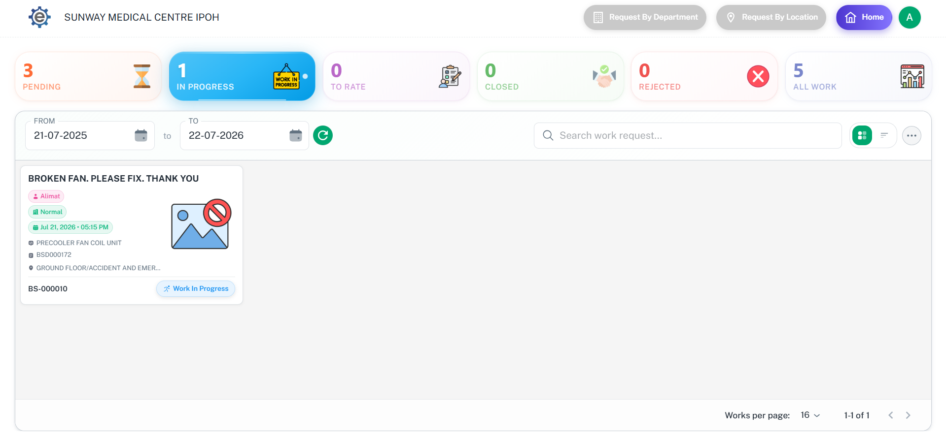
4.1 Click
4.2 Check

Acknowledge Request

Click ‘To Rate’ dashboard.

Click the work request that needs to be rating

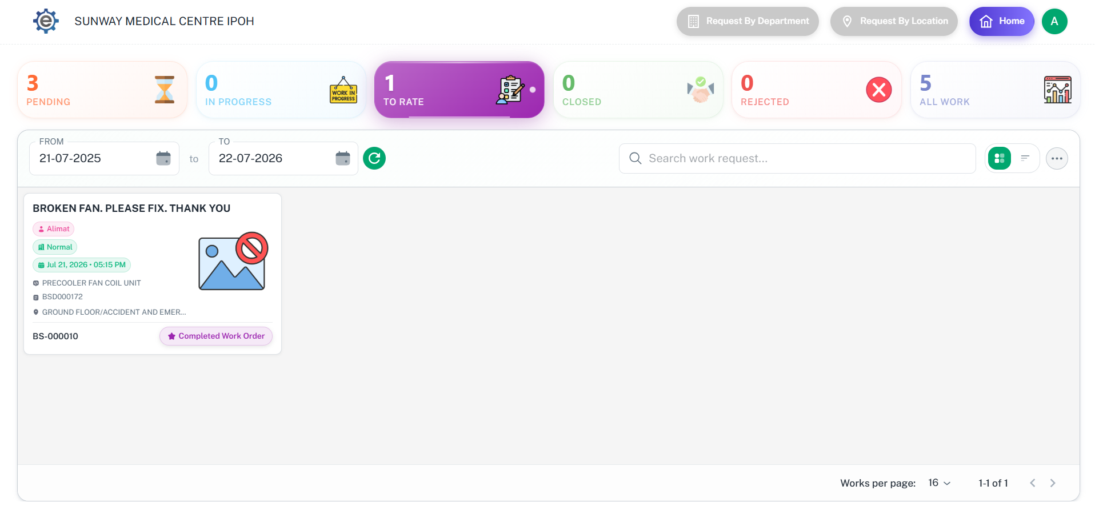
5.2 Click
5.1 Click

After clicking the work request, select status ‘Acknowledge’.

After that, you will need to provide rating for the job to complete the request, then click Acknowledge.
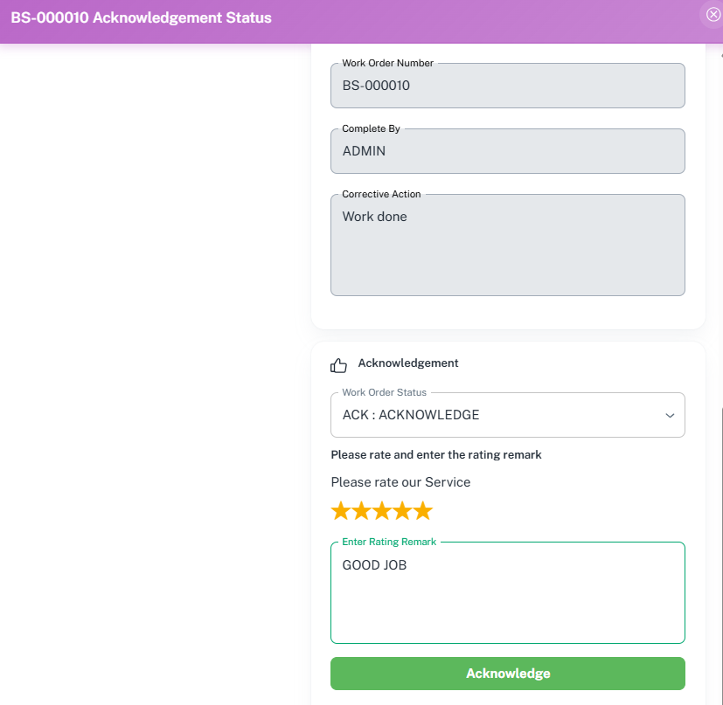
5.3 Click
5.4 Click

