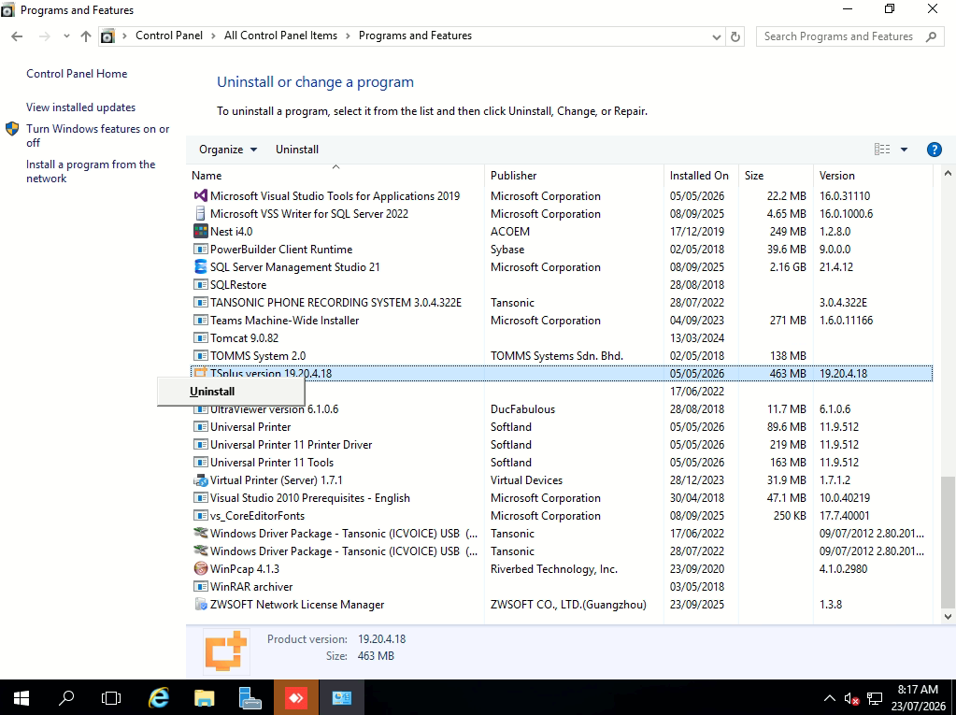
- Uninstall the TSPLUS.

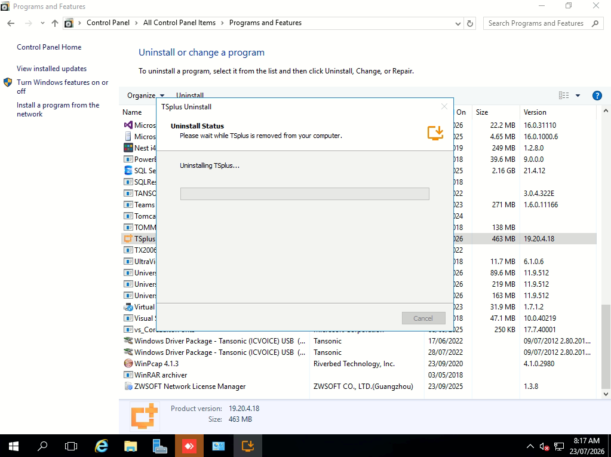
- Progressing.
- Once done it will request to restart server.
- Restart the server.

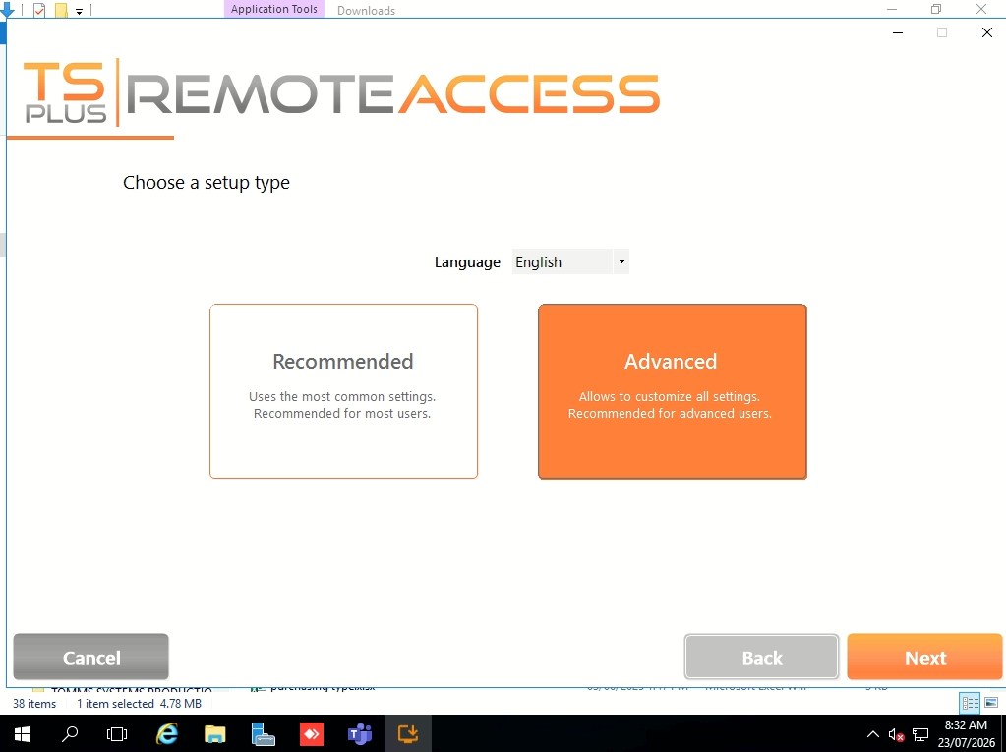
- Download the TSPLUS file from official website.
- Select Advance and NEXT.
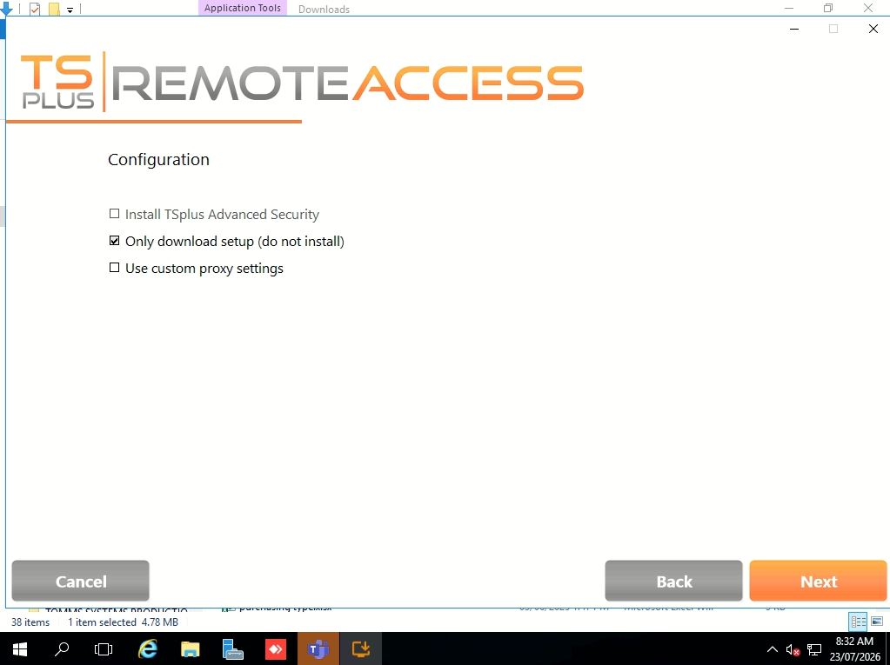
- Tick “Only download setup”
- Click Next.

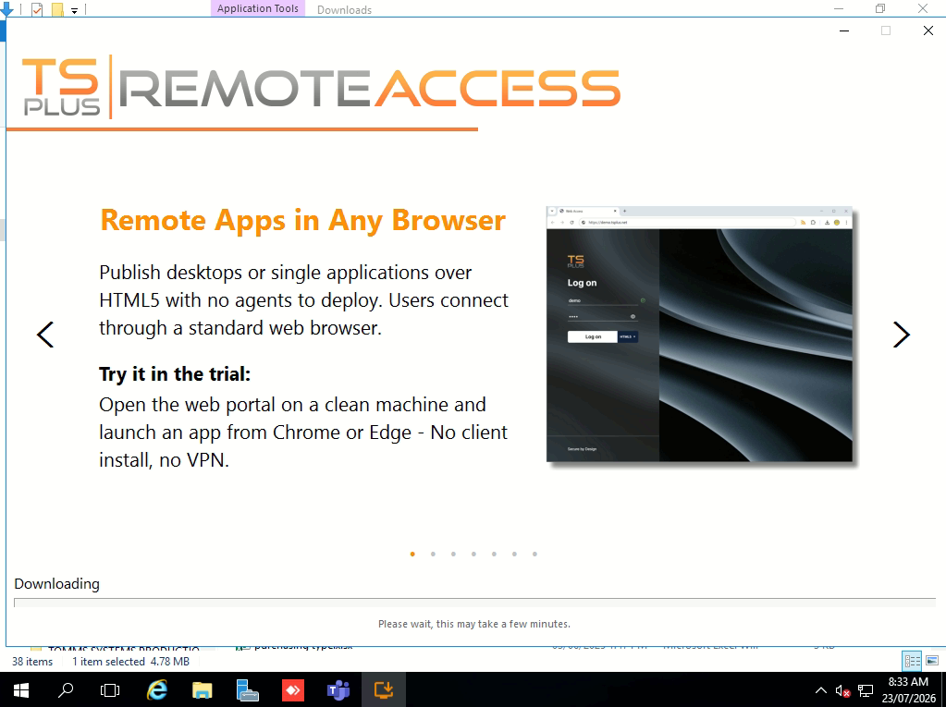
- Wait for finish download.

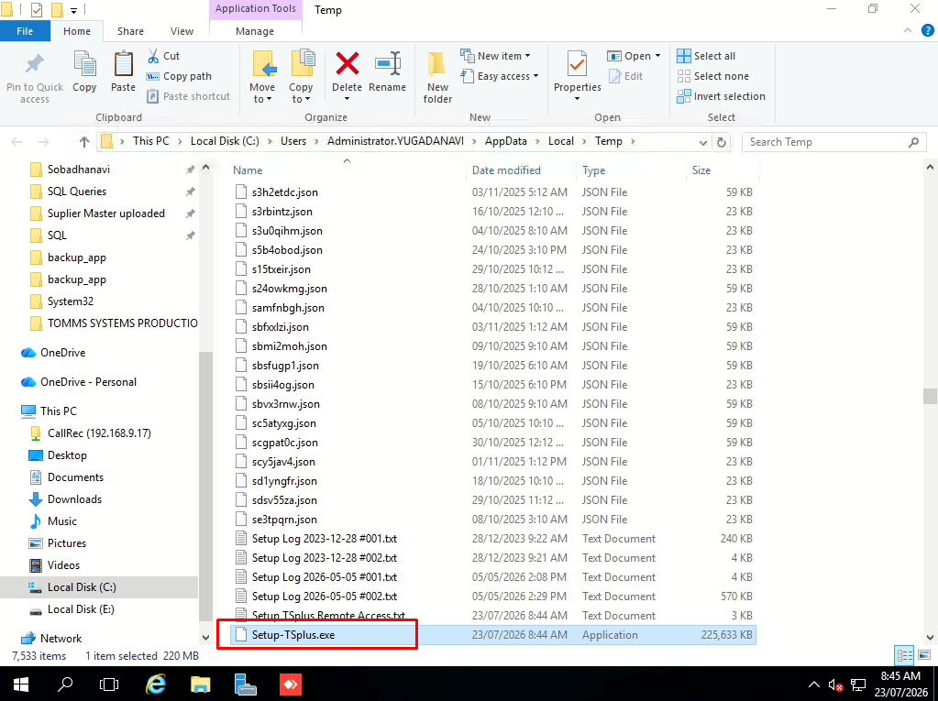
- Once downloaded done, it will open up a path where the offline install is.

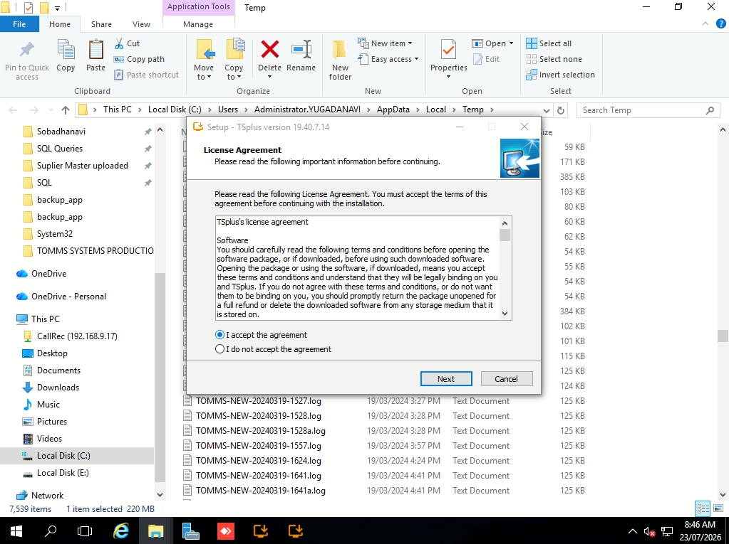
- Run the setup, Click Next.
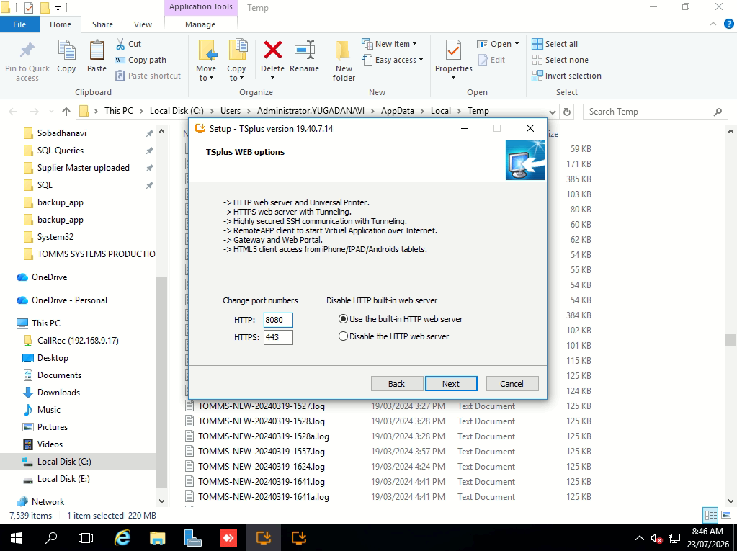
- Use the port 8080 in Lakdhanavi case. Default port 80.

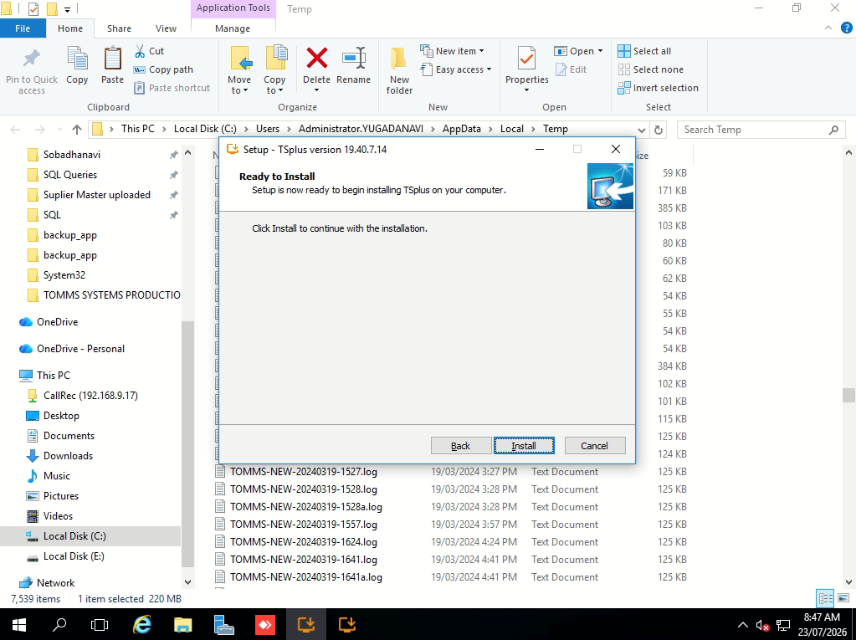
- Click Install.
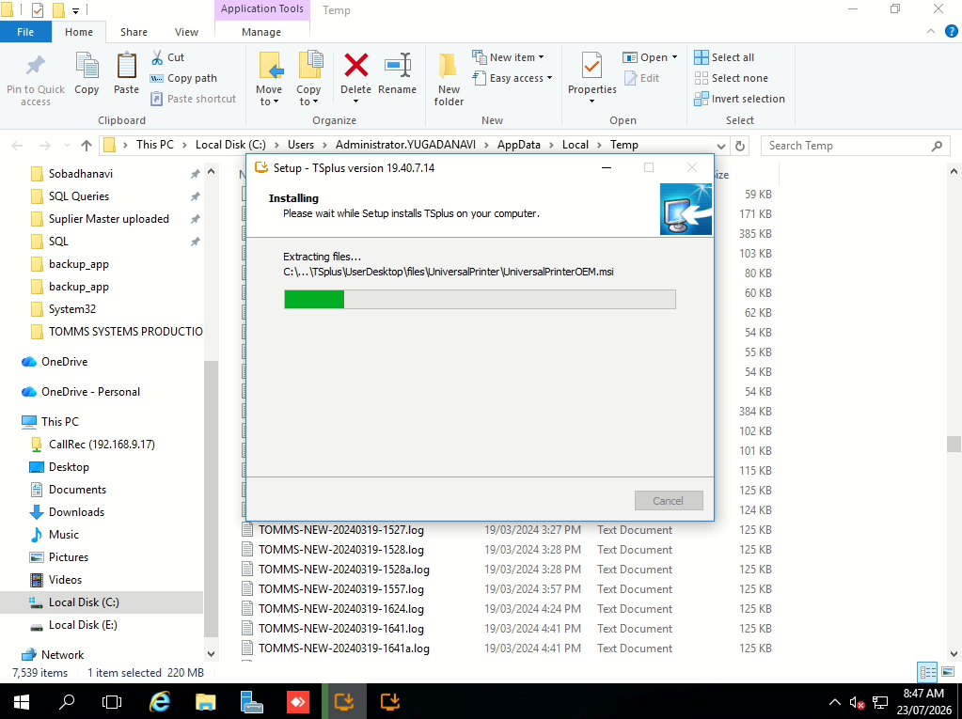
- Installing.

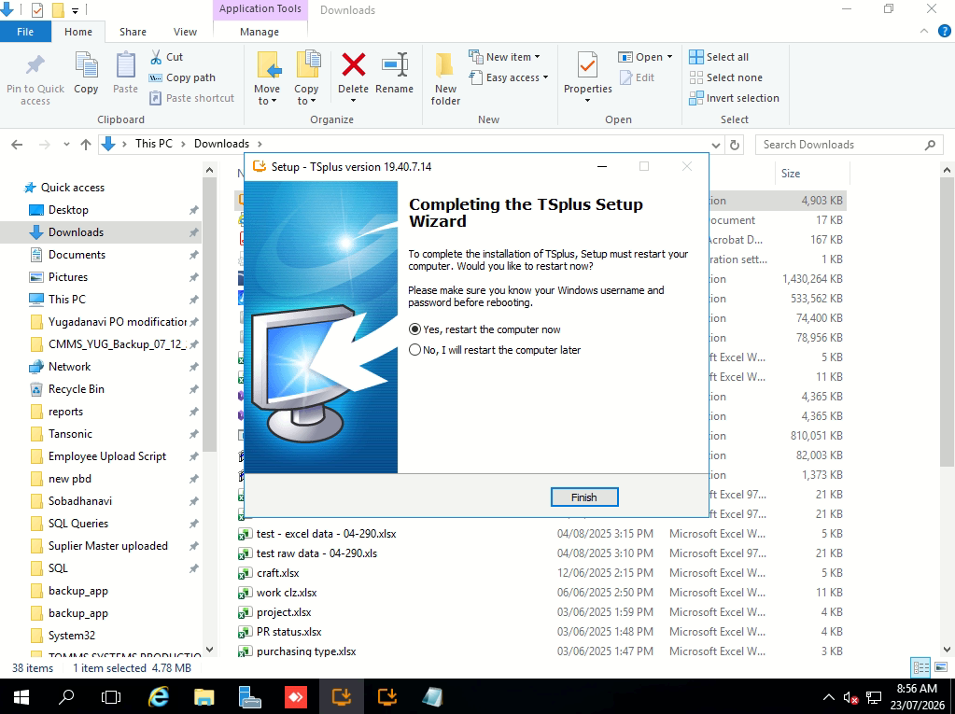
- Finish installation and Finish to restart.

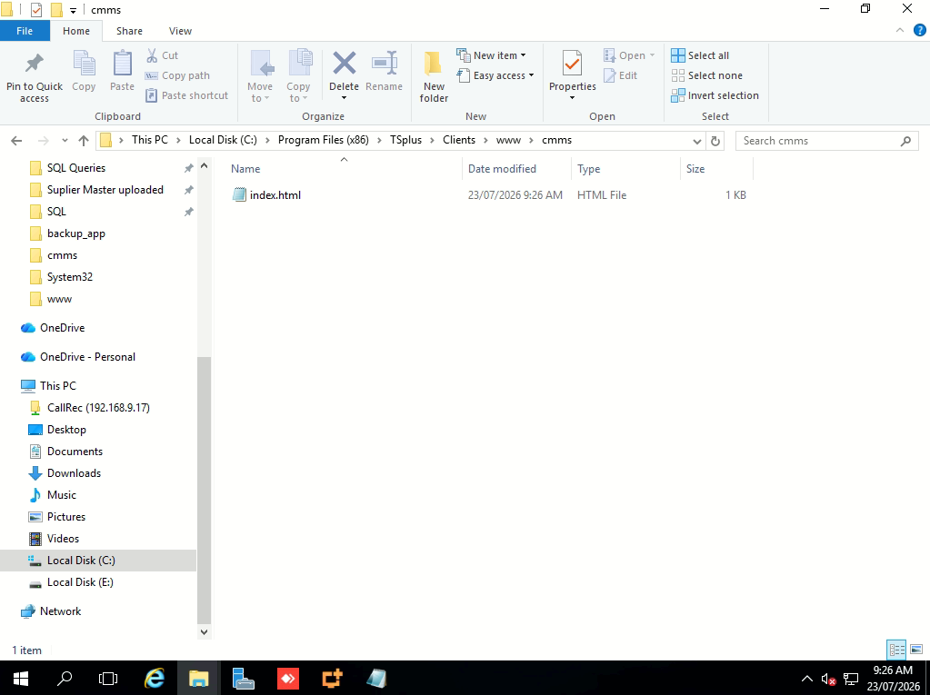
- Create a folder and put in the index_redirection.html.
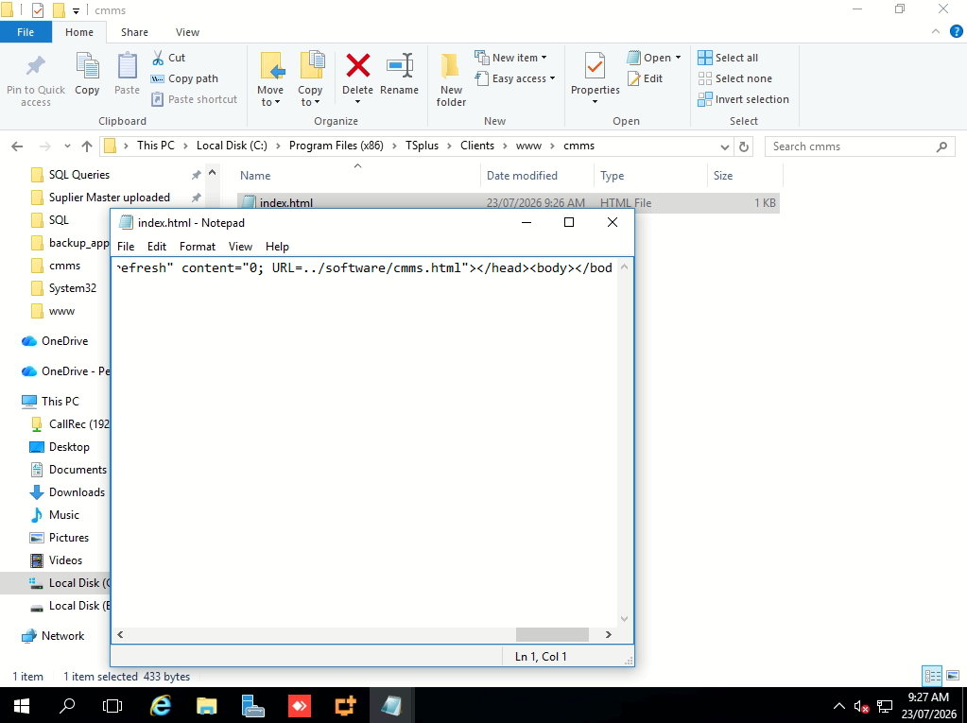
- Set to ../software/cmms.html.
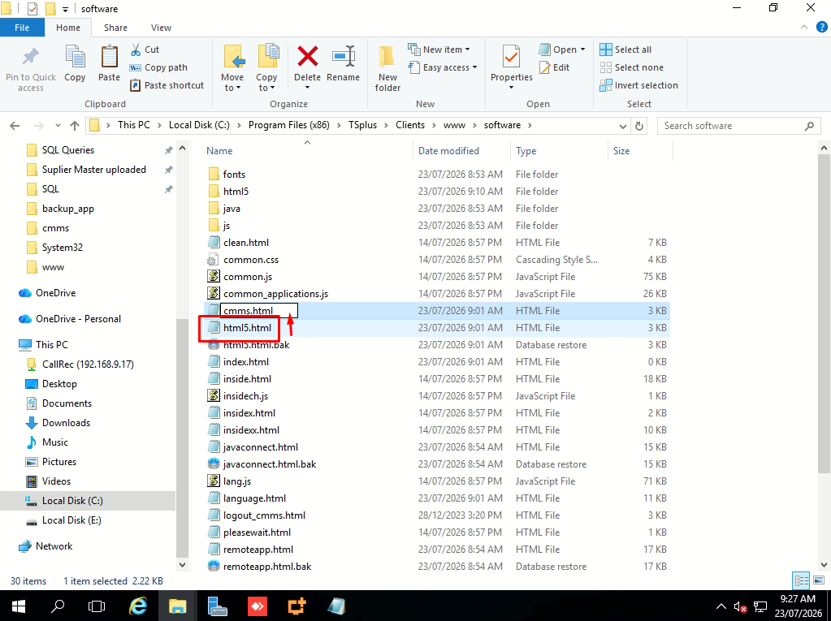18. Copy html5.html and rename to cmms.html.
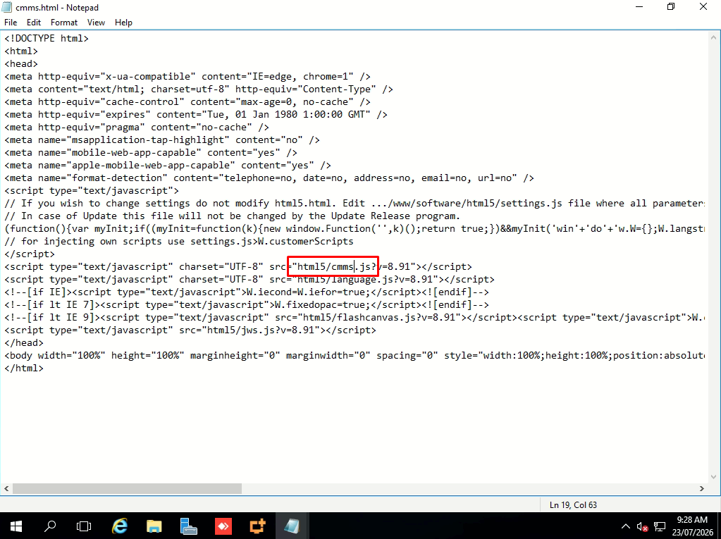
- Rename to cmms.js

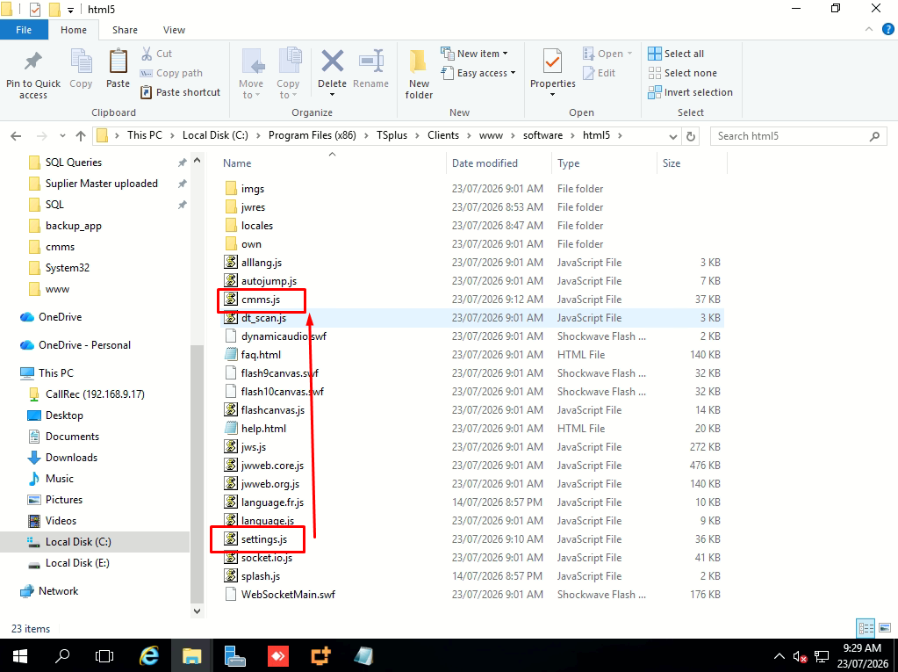
- On html5 folder, copy settings.js and rename to cmms.js.
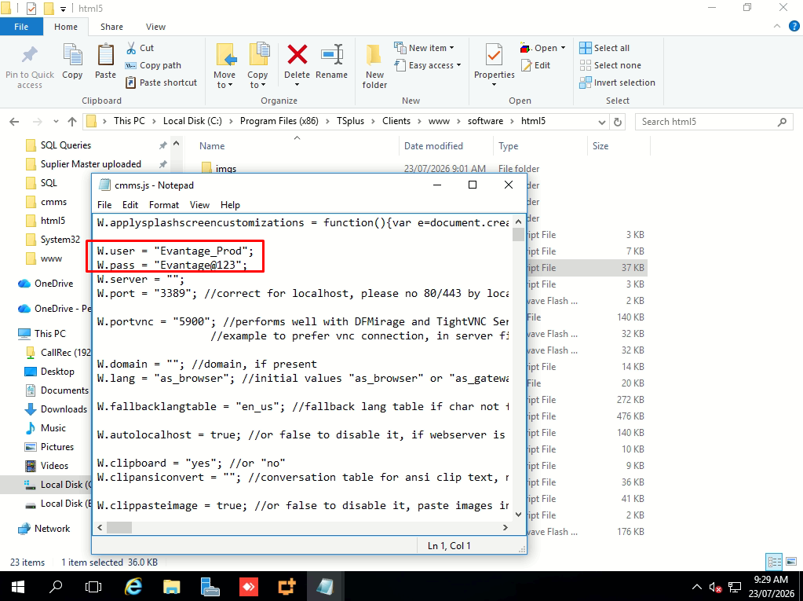
- Key in the necessary settings and username password.
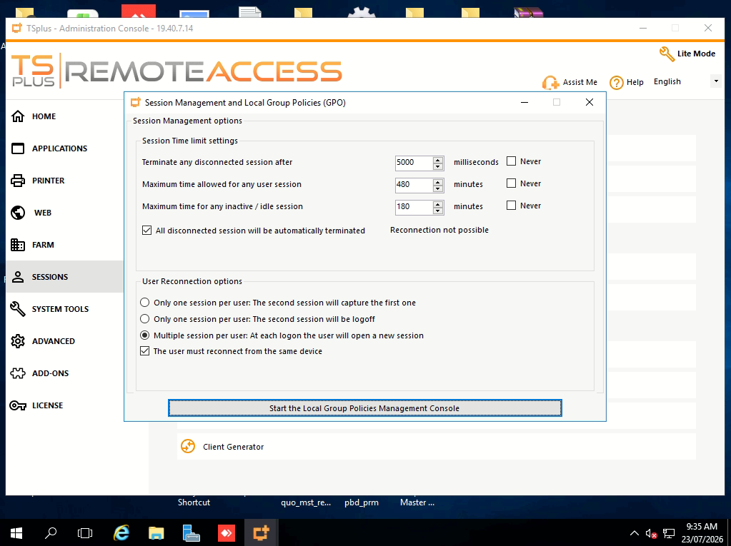
- Set the settings.

