

User Manual
For

Computerized Maintenance Management System (CMMS) - Maintenance

SMCI/SOP/001

DOCUMENT CONTROL

GENERAL INFORMATION

Document Name | : | User Manual for Computerized Maintenance System (CMMS) - Maintenance.
Intended To | : | Sunway Medical Centre Ipoh
Prepared By | : | Tamimi Hasbi
Creation Date | : | 1st July 2026
Revision | : | 1.0

DOCUMENT REVISION HISTORY
Revision  No | Revision  Date | By | Description of Changes
1.0 | 01/07/2026 | Tamimi Hasbi | User Manual for CMMS – Maintenance

DOCUMENT CONTROL 2
GENERAL INFORMATION 2
LOGIN 4
1 Login to the system 5
CMMS Core 5
CMMS Mobile 6
Asset Module 7
2 Asset Module – To Register a New Asset 8
3 Asset Module – Edit Asset 10
Inventory Module 13
4 Inventory Module – Inventory Master 14
5 Inventory Module – Edit inventory information 16
Maintenance Module 17
6 Work Request Module – Approve Work Request 18
7 Mobile Work Request Module – Approve Work Request 21
8 Mobile Work Order Module – Acknowledge Work Order 22
9 Work Order Module – Update Work Order 24
10 Mobile Work Order Module - Update Work Order 26
11 Mobile Work Order Module – Reassign Employee for Work Order 28
12 Core Work Order Module – Timecard 29
13 Mobile Work Order Module – Timecard 31
14 Work Order Module – Planning for Material 34
15 Mobile Work Order– Planning for Material 37
16 Work Order Module – Material Request Approval 40
17 Mobile Work Order Module – Material Request Approval 41
18 Inventory Module – Issue Transaction 42
19 Mobile Work Order Module – Issue Transaction 43
20 Inventory Module –Receive Misc Transaction 44
21 Mobile Work Order Module – Acknowledge Work Order 45
22 Work Order Module –Complete Work Order 47
23 Mobile Work Order Module –Complete Work Order 49
24 Work Order Module – Close Work Order 51
25 Mobile Work Order Module –Complete Work Order 53
26 PPM Master Module –Create Preventive Maintenance 55
27 PPM Master Module –PM Generate 57
28 Contract Module – Create New Contract 59

LOGIN

Login to the system

CMMS Core

Open the internet browser and enter the URL “http://10.9.1.34/cmms“, and login page will be open.

Insert login information:
Username | <Window ID>
Password | <Password>
*Note: Please use AD window id to login

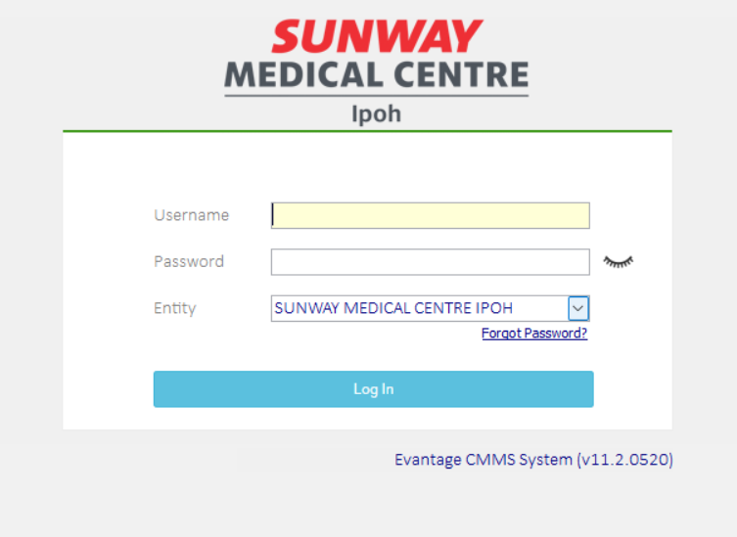
1.3 Click
1.2 Insert

Click on “Log In” button, and CMMS will be open if login success.

Please proceed:

If login unsucessfull

Incorrect Password: Please contact system admin to reset password.

Account Locked: Please contact system admin to unlock user login

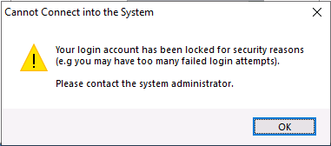
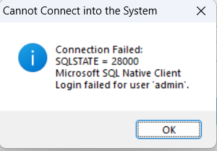
1.4.1.2
1.4.1.1

CMMS Mobile
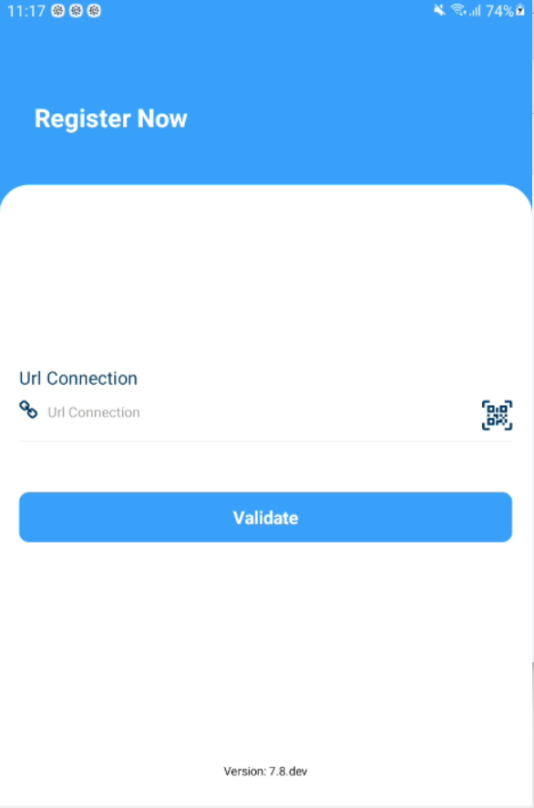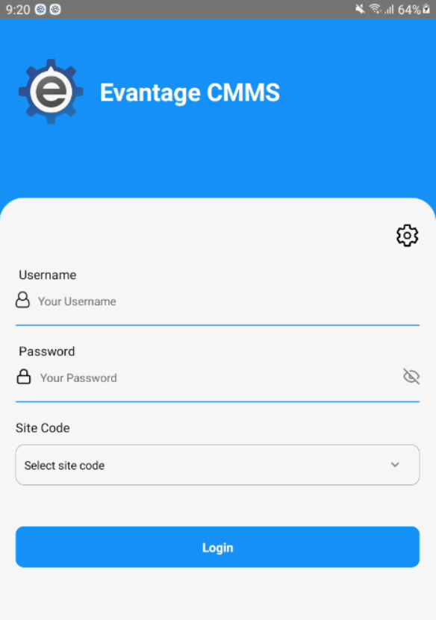
1.8 Click
1.7 Click
1.6 Click

Download the apps from the Playstore for Android or Appstore for IOS.

Open your apps and insert http://10.1.9.34/mobile

Insert login information:
Username | <Window ID>
Password | <Password>
*Note: Please use AD window id to login

Click on “Login” button, and CMMS apps will be open if login success.

If login unsucessfull

Incorrect Password: Please contact system admin to reset password.

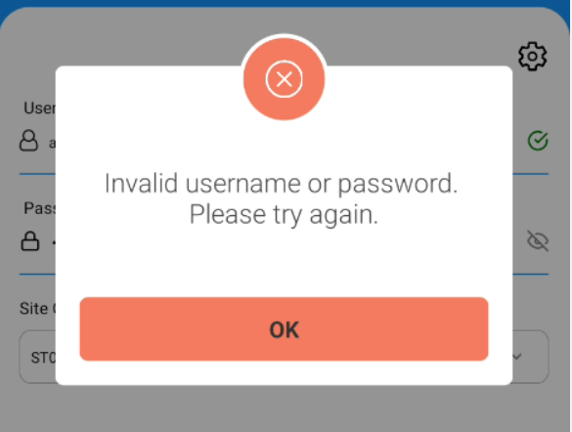

Asset Module

Asset Module – To Register a New Asset
(Note: Asset is mandatory to proceed with the Maintenance Work Flow, if not the asset will not be listed in the selection of Asset in the Maintenance Work Flow).

Click on “Asset” on User Menu to expand.

Click on “Asset Register”, and Asset table view open on the right.

Click on “New” button, and New Asset information viewer will be open.
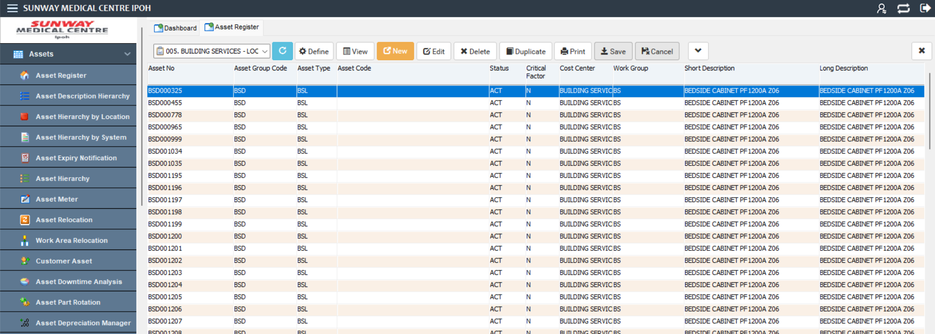
2.2 Click
2.1 Click
2.3 Click

Select asset group code first for “Asset No” to be generated.
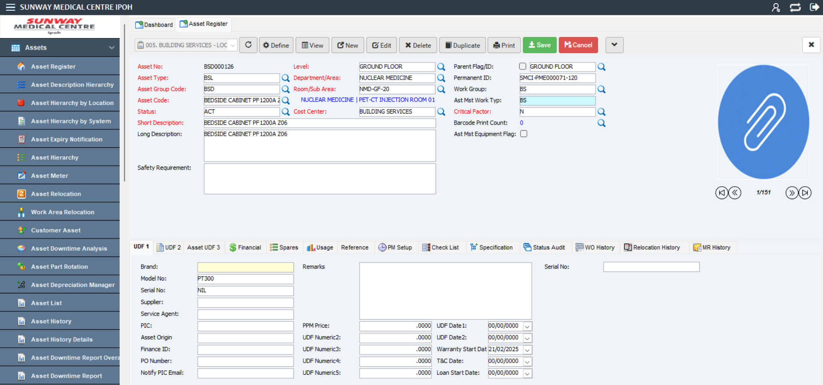
2.4 Insert asset information

Select/Insert Asset Information:
Field | Value | Have Master File?
Asset No | BSD000126(Auto Generate) | NO
Asset Type | BSD | YES
Asset Code | BEDSIDE CABINET P1200A 206 | YES
Asset Group Code | BSD (Determine Prefix Number) | YES
Status | ACT | YES
Critical Factor | N | YES
Level | GROUND FLOOR | YES
Department/Area | NUCLEAR MEDICINE | YES
Room/Sub Area | NMD-GF-20 | YES
Cost Centre | BUILDING SERVICES | YES
Short Description | Defibrillator/Monitors | NO
(Note: Master file is control by System Admin).

Click on “Save” button to confirm the creation of the asset, and message box with asset no generated will pop up.
2.6 Select / Insert
2.5 Select / Insert

Asset Module – Edit Asset

Click on “Asset” on User Menu to expand.

Click on “Asset Register”, and Asset table view open on the right.

Select Define and Query window will pop up.
3.1 Click
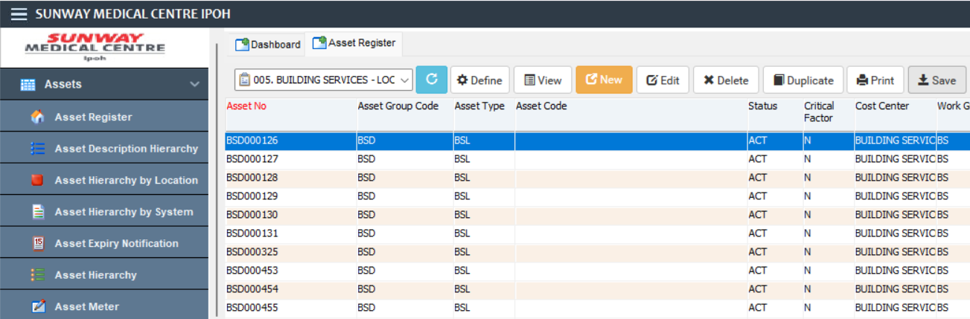
3.3 Click
3.2 Click

Key in define query criteria:
Field Name | Operator | Value
Asset No | Like | BED000126

Click on “OK” button, record will be shortlisted in the Asset table view.
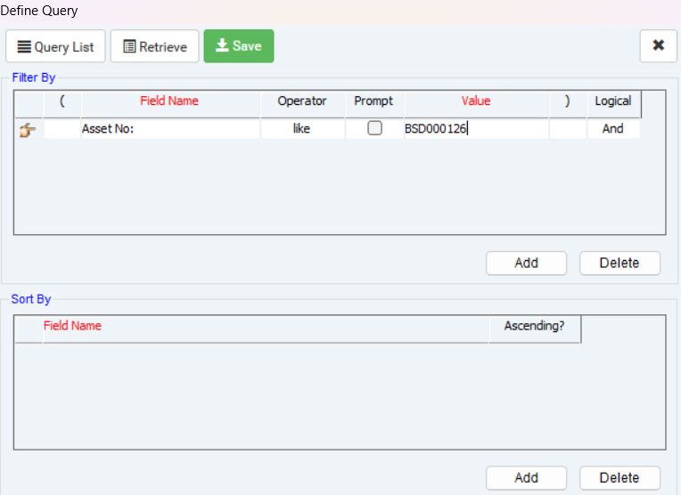
3.5 Click
3.4 Key in

Select Record to be edited.

Click on “Edit” button, and Edit Asset information viewer will open.
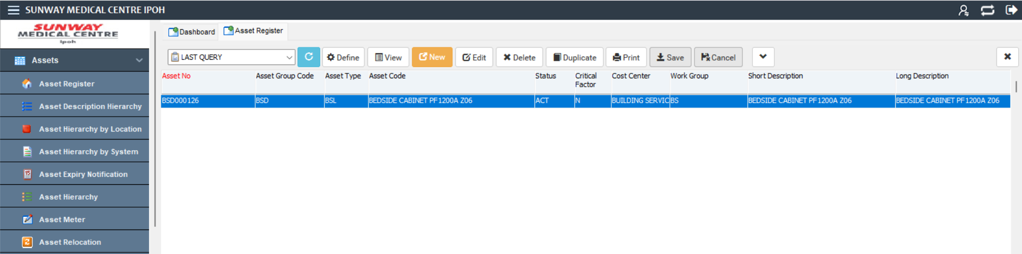
3.6 Select
3.7 Click

Click on tab “Financial”, and tab will open.
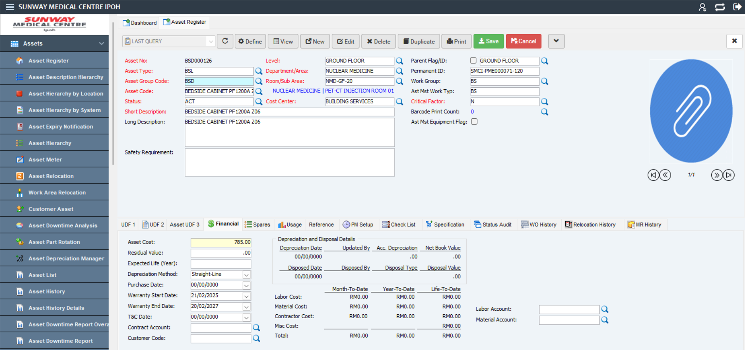
3.8 Click

Edit Asset informations:
Field | Value | Have Master File?
Asset Cost | 1,000 | NO
(Note: Master file is control by System Admin).

On “Financial” tab, fill in the information Asset Cost, Warranty Date,and other nescessary information.

Click on “Save” button, and Asset Information will be save and redirect back to table view.
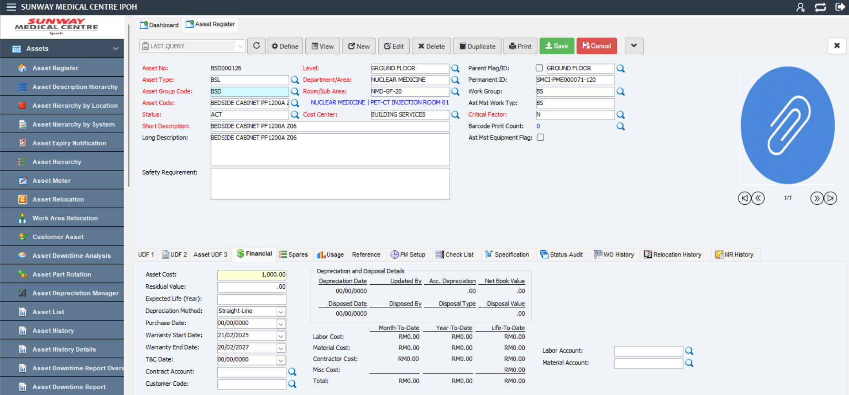
3.10 Enter / Key In
3.11 Click

Inventory Module

Inventory Module – Inventory Master
(Note: Inventory is mandatory to proceed with the Maintenance Work Flow, if not the stock will not be listed in the selection of stock in the Maintenance Work Flow).

Click on “Sparepart” on User Menu to expand.

Click on “Inventory Master”, and Inventory table view open on the right.

Click on “New” button to create new stock.

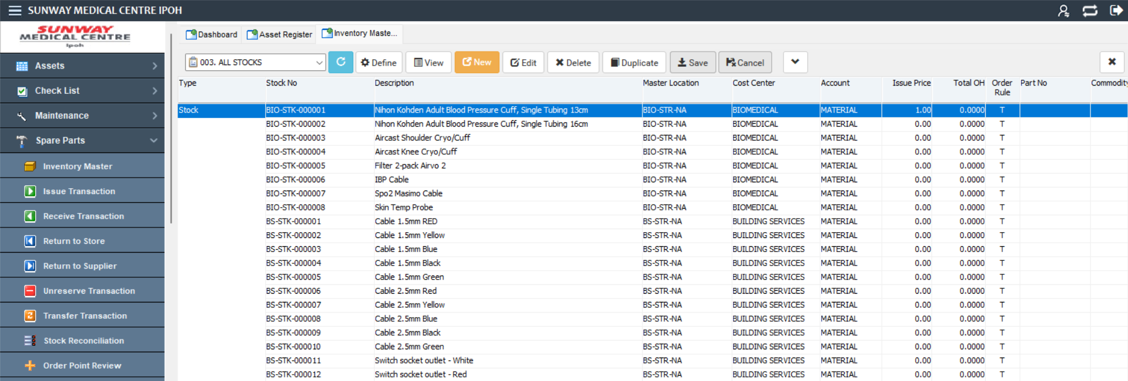
4.3 Click
4.2 Click
4.1 Click

Select/Insert Asset Information:

**(You need to select cost centre first to generate the latest stock No)

Field | Value | Have Master File?
Cost Centre | BIOMEDICAL (Determine Stock No Prefix) | YES
Type | Stock | YES
Stock No | BIO-STK-000001 (Auto Generated Latest running no) | YES
Master Location | BIO-STR-NA | YES
Order Rule | T | YES
Description | Nihon Kohden Adult Blood Pressure Cuff, Single Tubing 13cm | NO
Part Deac Status | ACT | YES
Issue UOM | PIECES | YES
Receive UOM | PIECES | YES
(Note: Master file is control by System Admin).

Click the “Save” button to complete the stock registration process. Stock no will be assigned and saves.
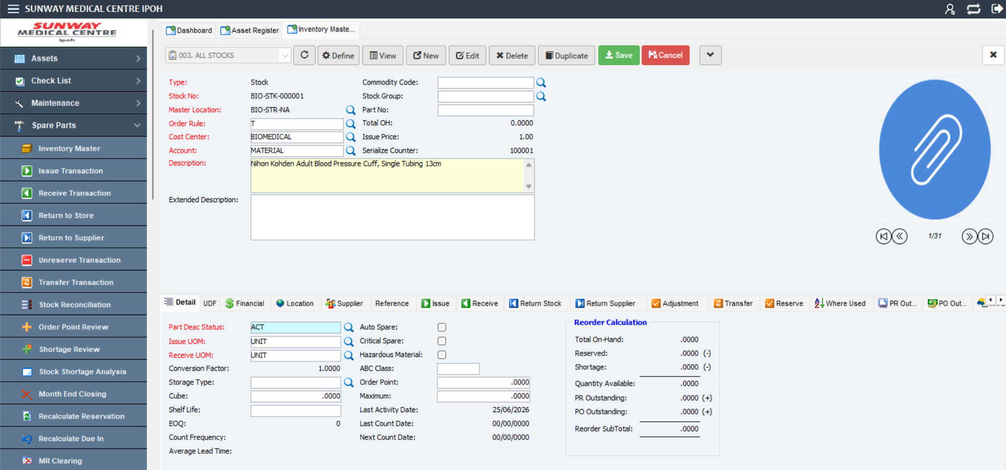
4.5 Select
4.4 Insert/Select

Inventory Module – Edit inventory information
(Note: Inventory is mandatory to proceed with the Maintenance Work Flow, if not the stock will not be listed in the selection of stock in the Maintenance Work Flow).

Click on “Spare Parts” on User Menu to expand.

Click on “Inventory Master”, and Inventory table view open on the right.

Click by highlighting the stock that you wish to change.

Click on the“Edit” button to edit the stock.
5.4 Click
5.2 Click
5.1 Click
5.3 Click

Edit stock informations:
Field | Value | Have Master File?
Order Point | 3 | NO
Maximum | 10 | NO
(Note: Master file is control by System Admin).

Click the “Save” button to complete the editing process.
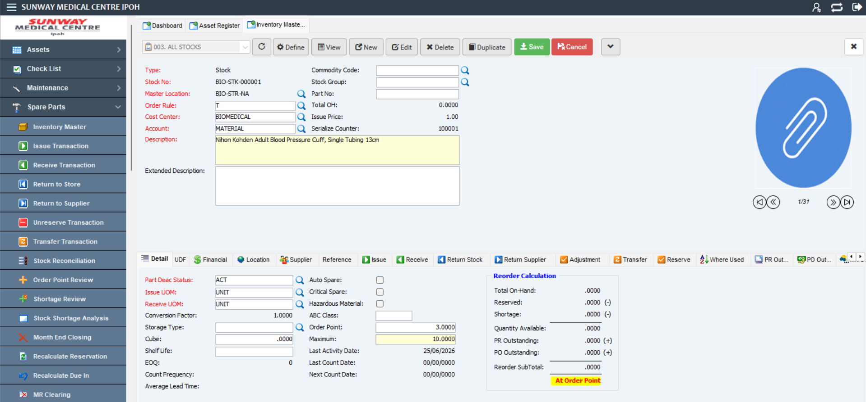
5.5 Click
5.6 Click

Maintenance Module

Work Request Module – Approve Work Request

Click on “Maintenance” on User Menu to expand.

Click on “Work Request”, and Work request table view will be open on the right.
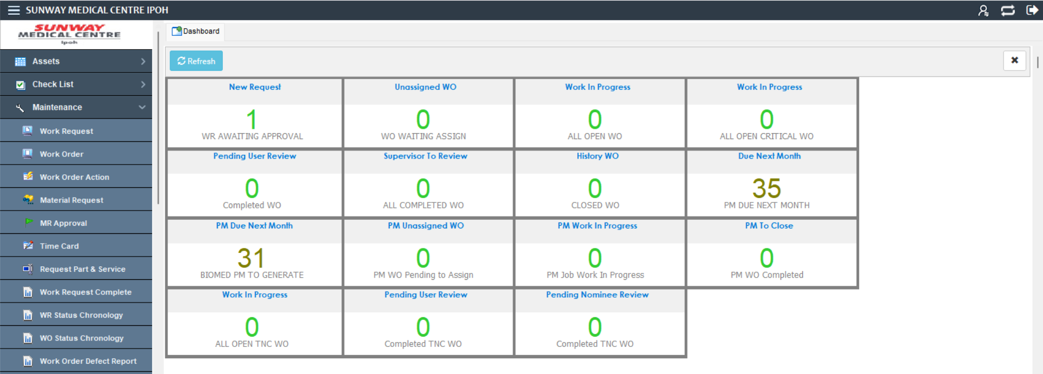
6.2 Click
6.1 Click

Click on “Define” to search and display work request.
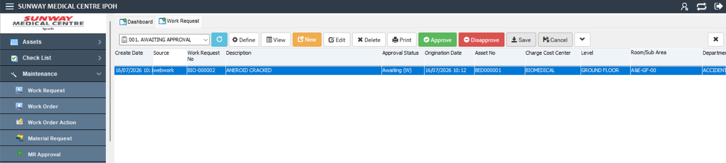
6.3 Click

Select/Insert Asset Information:
Field Name | Operator | Value
Work Request No | LIKE | BIO-000002

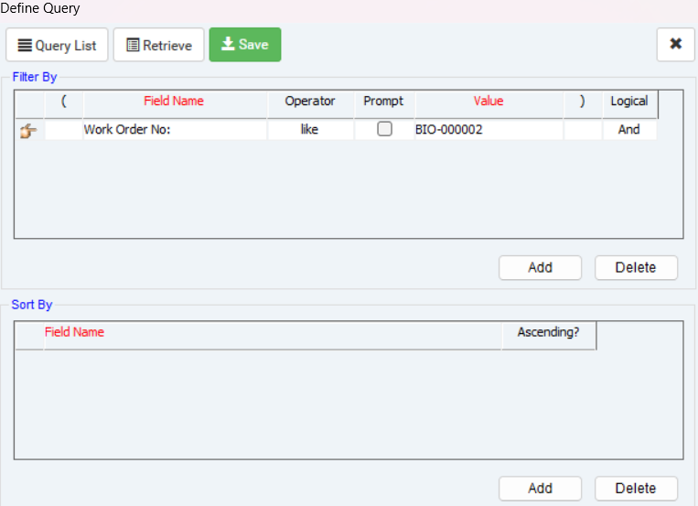
6.4 Click

User can also click “New Request” on the dashboard. All work request pending approval under user work group will be display.
6.5 Click

Click “Approve” to approve the work request.
6.6 Click

Before the work request convert into work order, supervisor needs to assign the work order to the technician.

Click “Save” to complete the process
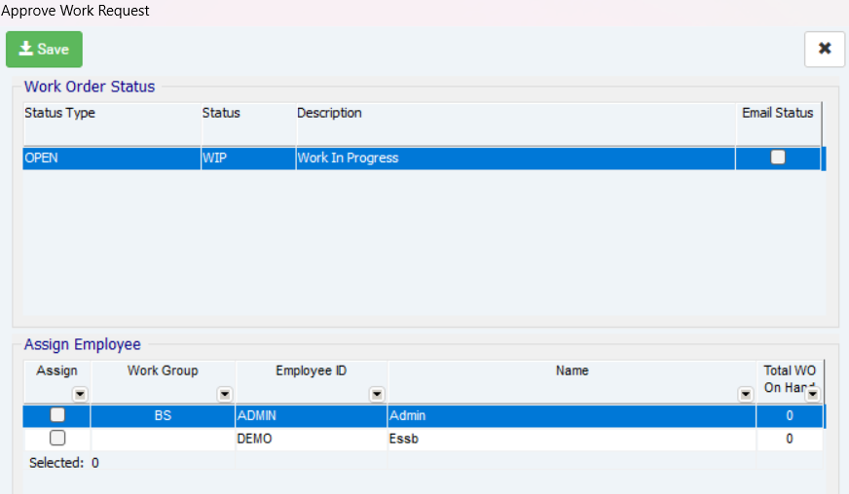
6.7 Click
6.8 Click

Work order number will be create and assigned to the technician.
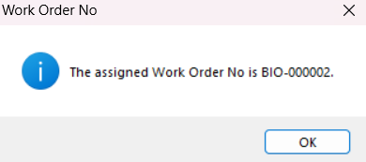

Mobile Work Request Module – Approve Work Request

On the homepage, Click on “Work Request” > ‘WR Approval’ on User Menu to expand.

Tap on the work request that want to be Approve/Disapprove.

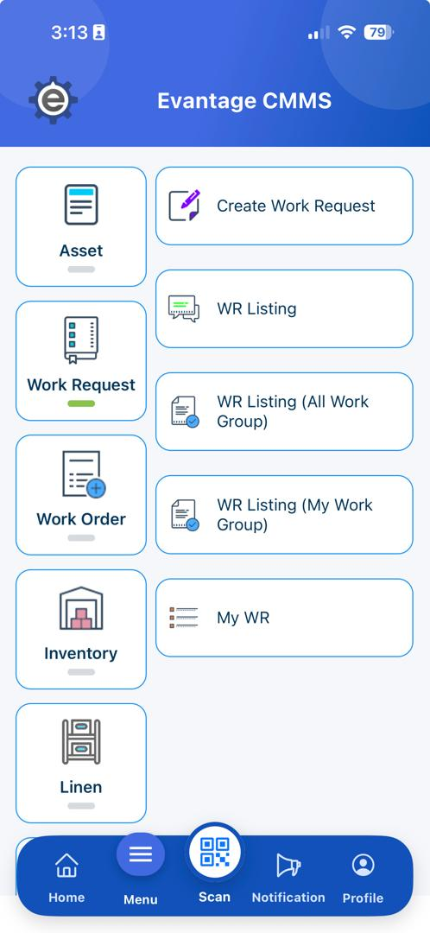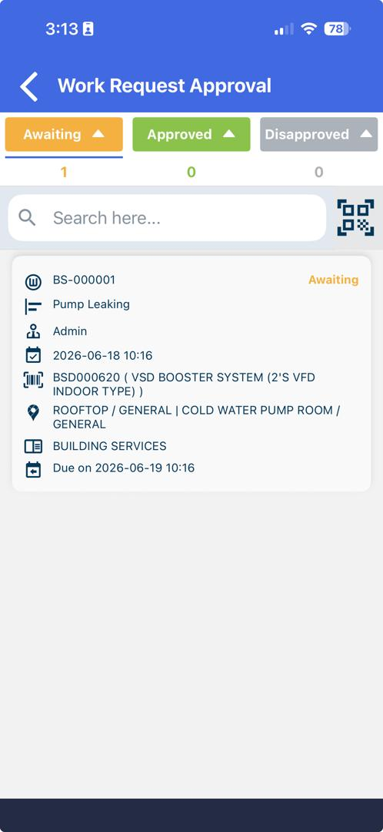
7.1 Tap
7.2 Tap

User can review the work request and if satisfied, user can tap on the”Approve” or “Disapprove” button.

Before completing the approval, user need to assign to technician and select the work order status as well as the work group. Click “OK” to proceed. The work order no will be created and assigned to the technician.
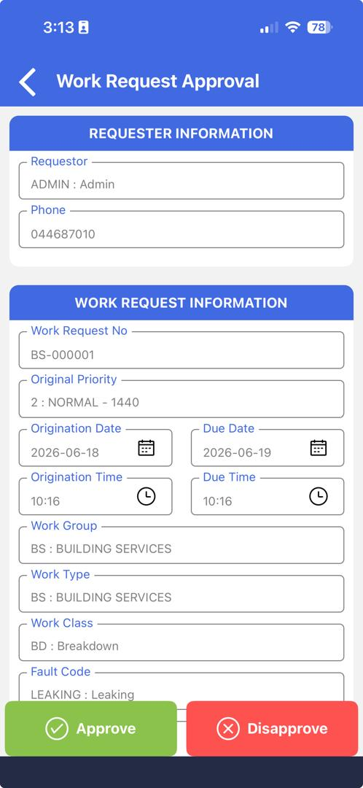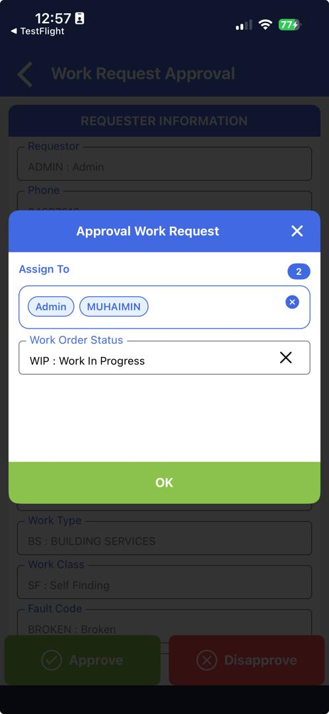
7.3 Tap
7.4 Tap

Mobile Work Order Module – Response Work Order

Click on “Work Order” on User Menu to expand.

Click on “My Work Order”, and work order assigned to the technician view will be open on the right.

Search or select the work order to be change to complete.
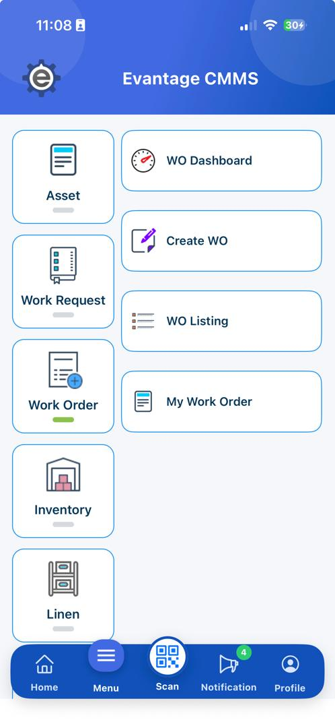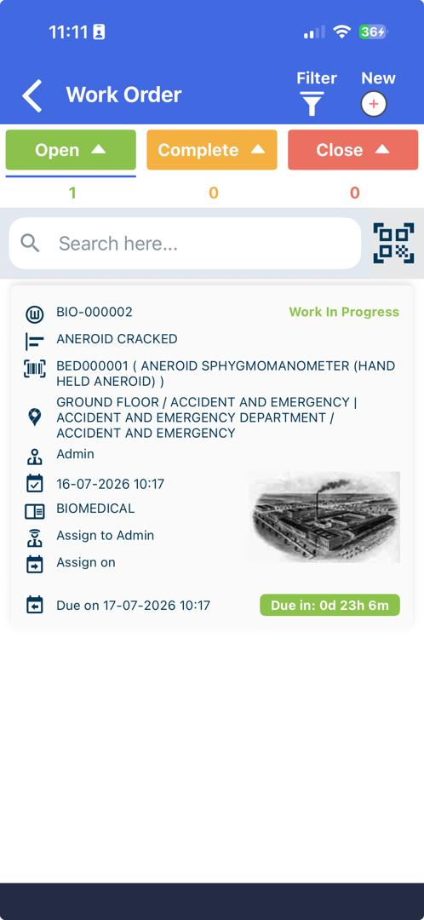
8.2 Tap
8.1 Tap
8.3 Tap

Click on “More” to expand the menu.

Click on “Response”.

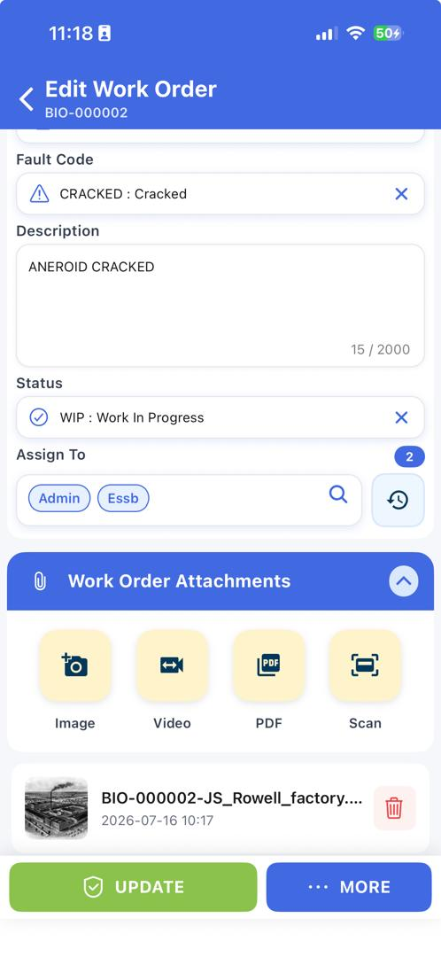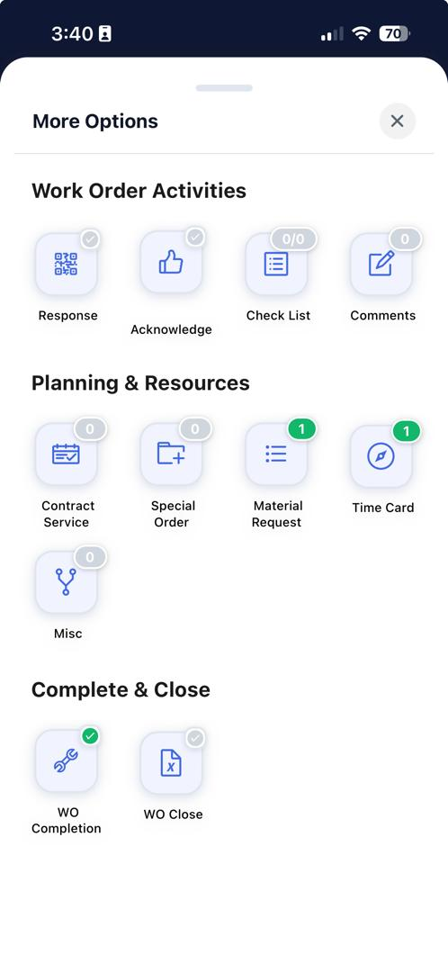
8.5 Tap
8.4 Tap

Insert below information in the column based on the value:
Field | Value | Have Master File?
Response Name | Tamimi | No
Response ID | 1111 | No
Contact | 123 | No

Tap Add Signature and obtain the requestor's signature.

Tap Confirm button to save the signature.

Tap Save button to save the Response.

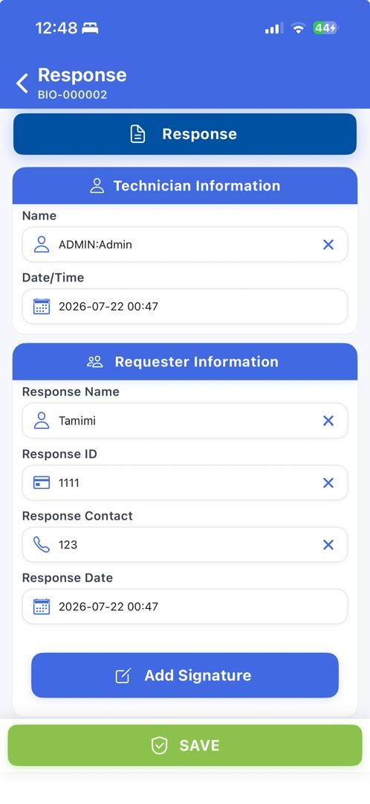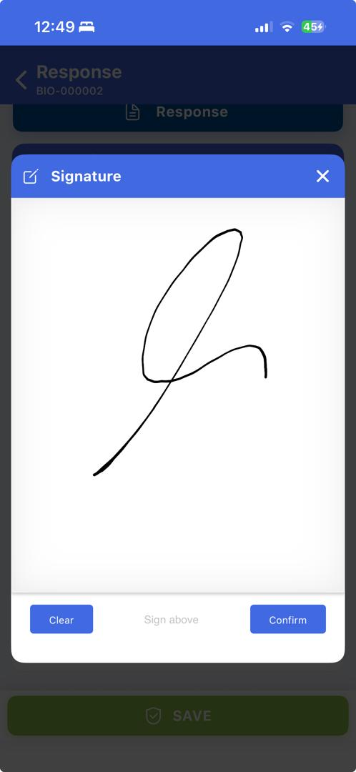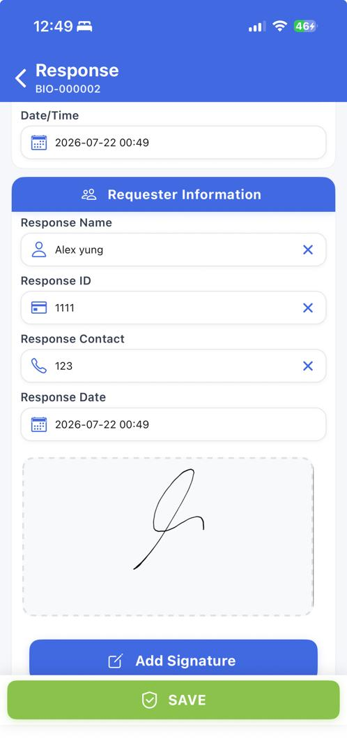
8.8 Tap
8.7 Tap
8.8 Tap
8.6 Insert

Work Order Module – Update Work Order
(Note: Work Order that has been carried out and completed, Maintenance Team will update the Work Order in the system accordingly).

Under the Dashboard screen click “My Work Order”.
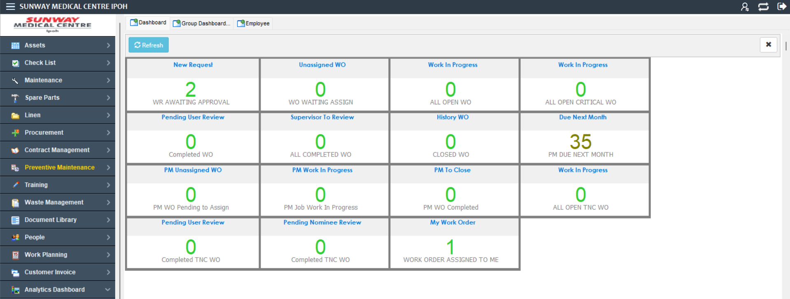
9.1 Click

Select record.

Click on “Edit” button, and Edit Work Order information viewer will open.
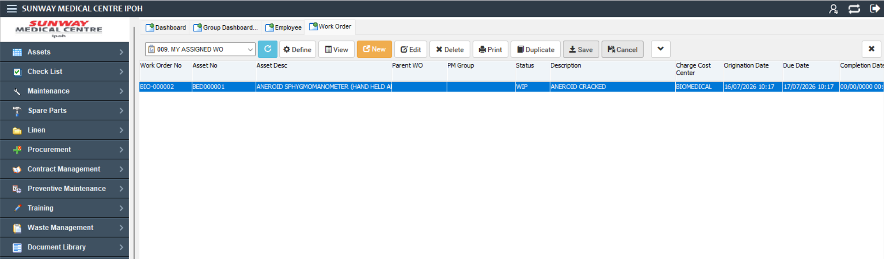
9.3 Click
9.2 Select

Update Work Order information:
Field | Value | Have Master File?
Fault Code | CRACKED | YES
Action Code | REPLACE | YES

Click on “Save” button, and User will be redirect to table view.

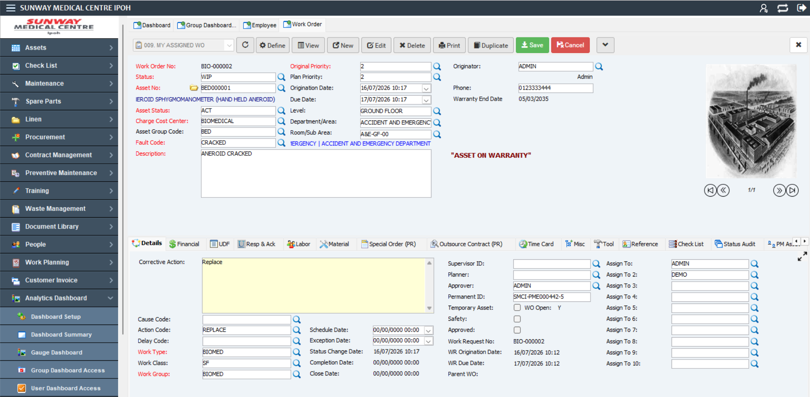
9.4 Update
9.4 Update
9.5 Click

Mobile Work Order Module - Update Work Order
(Note: Work Order that had been carried out and completed, Maintenance Team will update the Work Order in the system accordingly).

Tap on “Work Order” on User Menu to expand.

Tap on “My Work Order” to view user assigned Work Order.

Tap to view the work order.

10.2 Tap
10.1 Tap
10.3 Tap

Tap on “Edit” to edit the Work Order.

Tap on “Fault Code” .

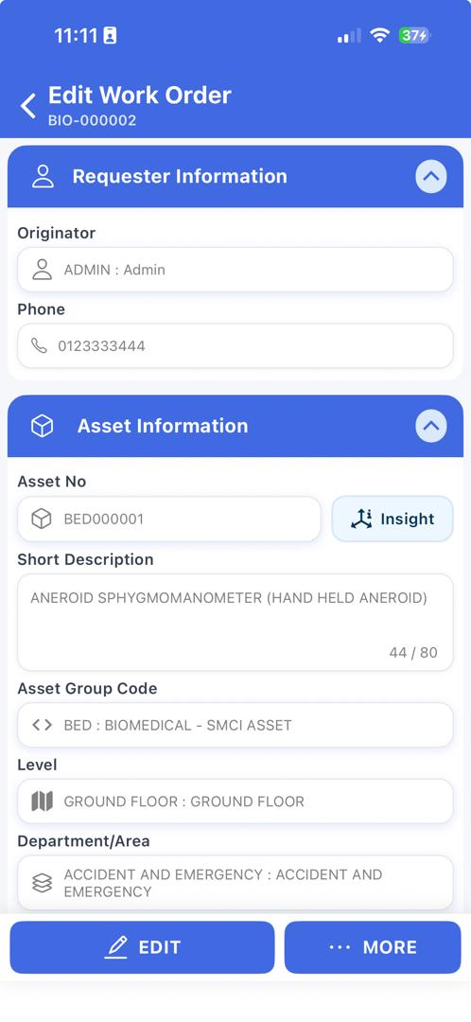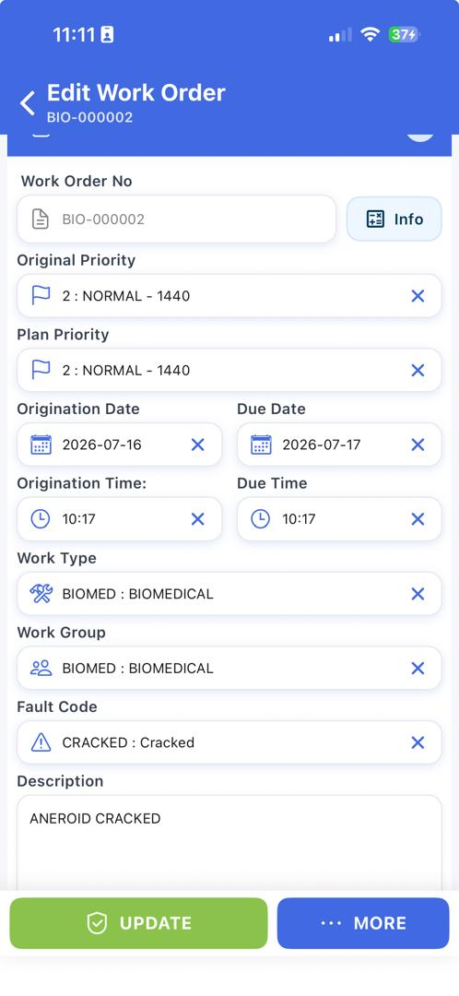
10.5 Tap
10.4 Tap

Click “Broken” based on the new updated value .
Field | Value | Have Master File?
Fault Code | CRACKED | YES

Click “Update” to update the work order .

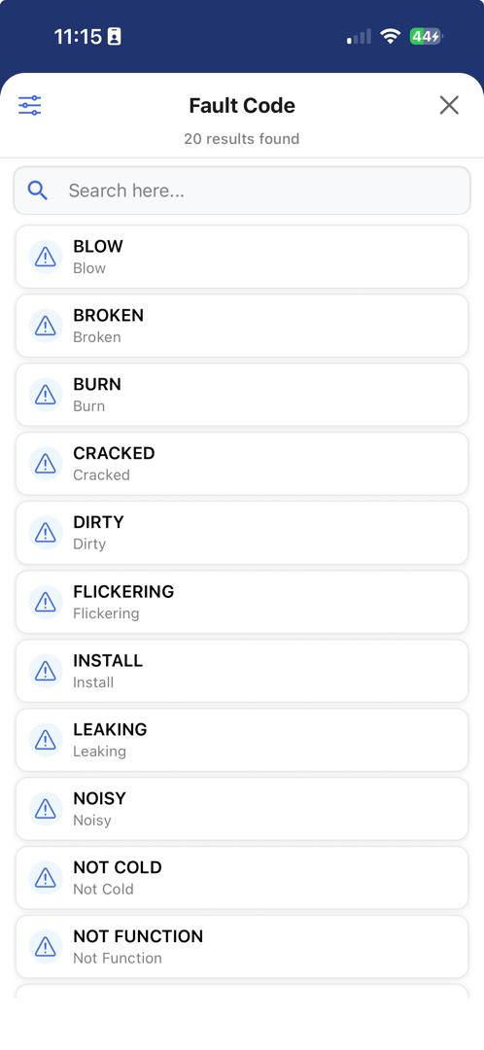
10.7 Tap
10.6 Tap

Mobile Work Order Module – Reassign Employee for Work Order

Tap on “Work Order” to expand work order module

Tap on “My Work Order” to retrieve user own work order.

Search and tap on the work order to be reassigned.

11.2 Tap
11.1 Tap
11.3 Tap

Tap on “Assign To” to retrieve technician list.

Search and tap on the technician to be assigned.

Please insert reason to reassign the work order.

Tap on the”Update” button to complete the process of reassigned technician.

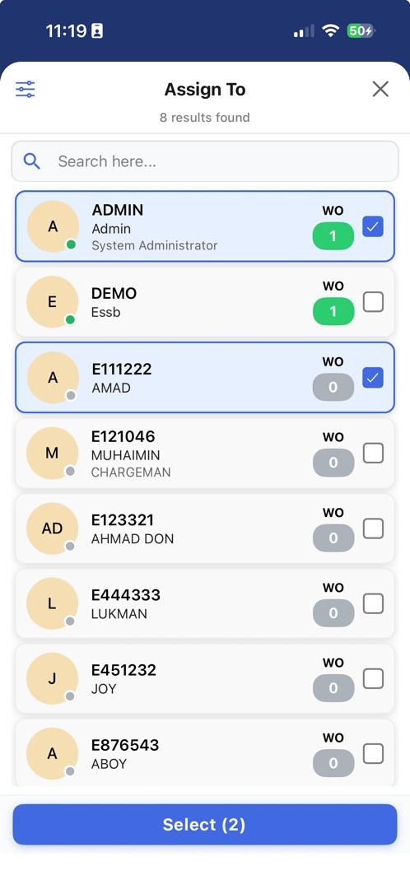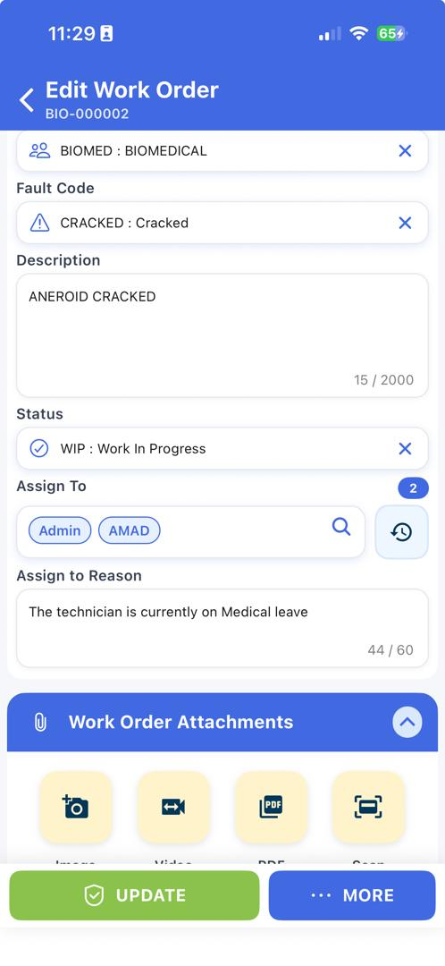
11.5 Tap
11.6 Tap
11.4 Tap
11.7 Tap

Core Work Order Module – Timecard
(Note: This is to make a Timecard Planning for Work Order, to proceed with this make sure the craft had been configured).

Under Dashboard > “My Work Order”.
12.1 Click

Select record.

Click on “Edit” button, and Edit Work Order information viewer will open.
12.2 Click
12.3 Select

Click on “Time Card” tab.

Click on “Add” button, and new line of Time Card will be added.

Double click in the “Employee ID” field, and Employee ID window will pop up.

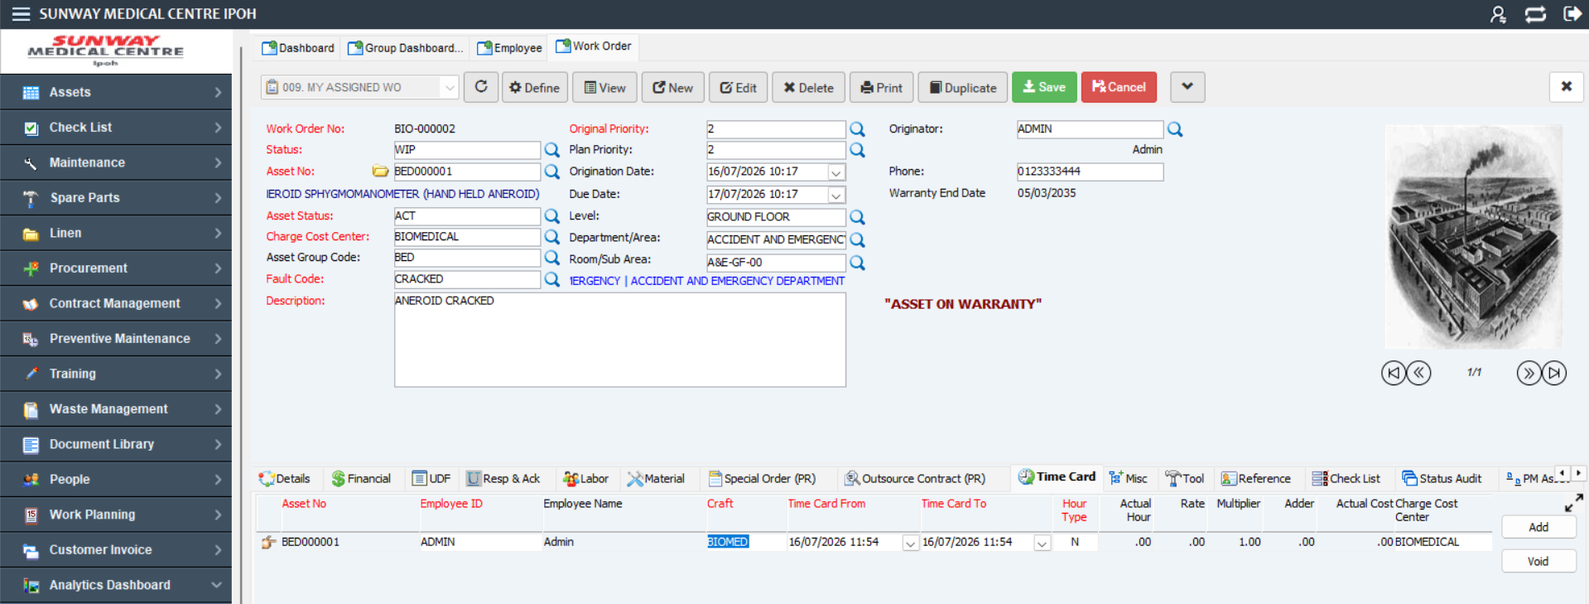
12.4 Click
12.5 Click
12.6 Double Click

Select “Employee ID: Admin”.

Click on “Select” button, and selected employee id information will be added in the time card line.

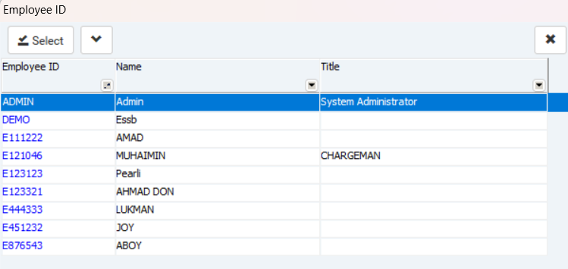
12.7 Select
12.8 Click

Click on “Save” button, and User will redirect back to table view.
(Note: To add another employee to the timecard, repeat step 12.7 to 13.10).

12.9 Click

Mobile Work Order Module – Timecard
(Note: This is to make a Timecard Planning for Work Order on mobile, to proceed with this make sure the craft had been configured).

Tap “Work Order” on User Menu to expand.

Tap “My Work Order” to view user assigned Work Order.

Tap to view the work order.
13.2 Tap
13.1 Tap
13.3 Tap

Tap “More” to expand the menu.

Tap “Time Card”.
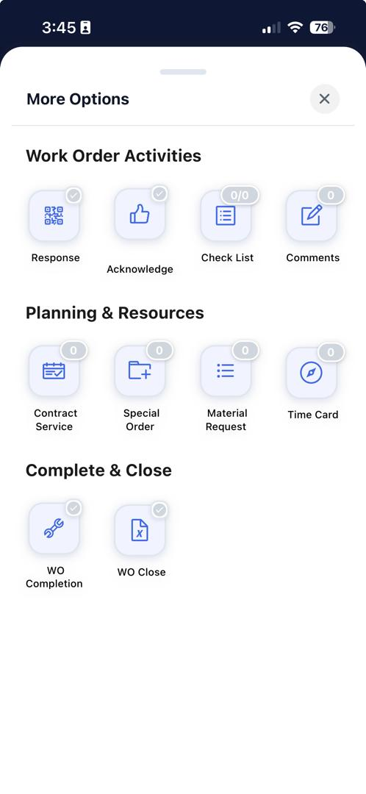
13.5 Tap
13.4 Tap

Tap on “Start” to display time card line .

Tap “Hour Type” to expand the list and select Normal Hour.
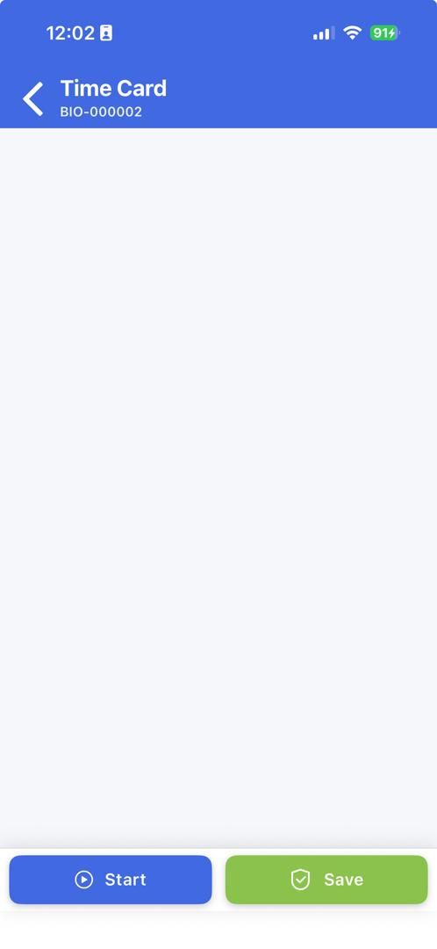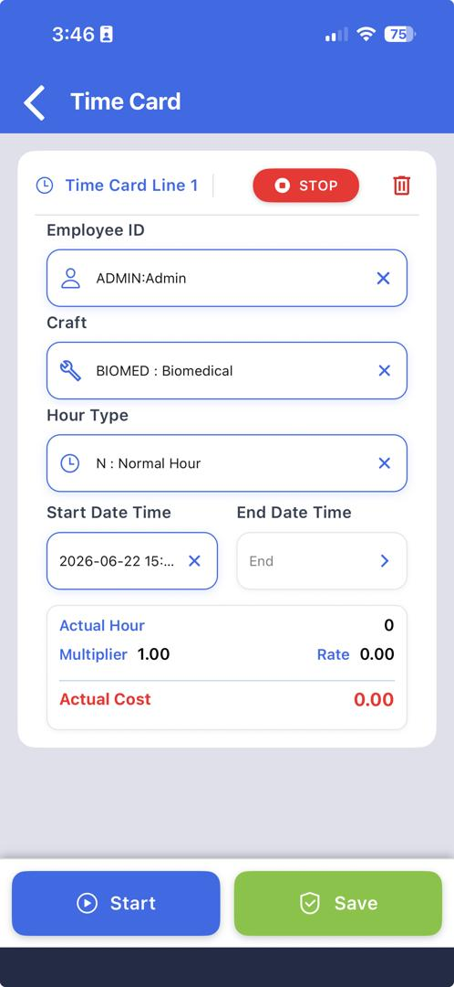
13.7 Tap
13.6 Tap

Click “Save” to save the time card and user can start the maintenance activity.
13.8 Tap

Click “Stop” to stop the time card and the “End Date Time” is record.

Click “Save” to save the time card and User will be redirect back to “More” view.
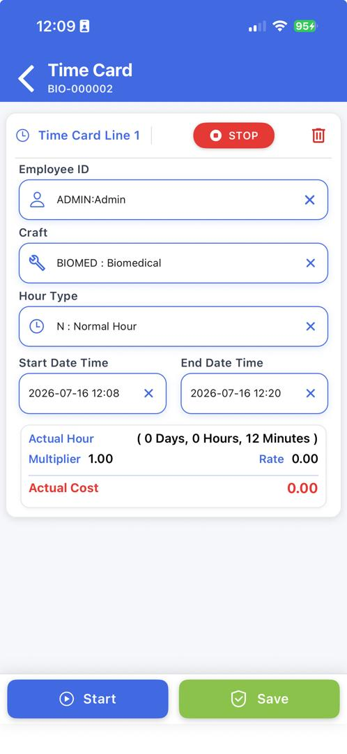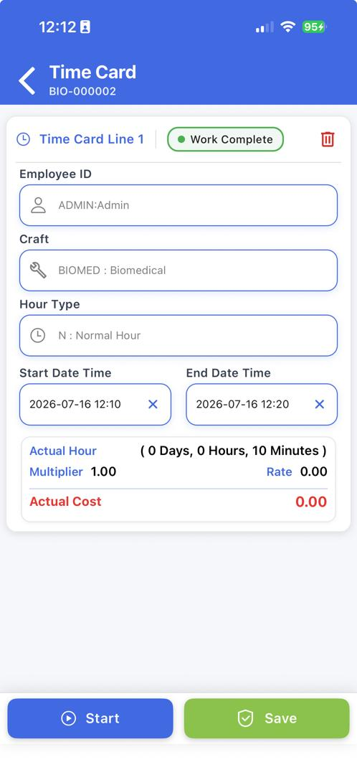
13.10 Tap
13.9 Tap

Work Order Module – Planning for Material
(Note: This is to create Material Planning for Work Order. To proceed, please ensure the Inventory had been configured)

Navigate to the dashboard.

Click on “My Work Order”, and Work Order table view will be open on the right.

You can also select pre-set Define Query “009 MY ASSIGNED WO”, and table view will be refreshed.
14.2 Click

Select record.

Click on “Edit” button, and Edit Work Order information viewer will open.
14.5 Click
14.4 Select

Click on “Material” tab.

Click on “Add” button, and new line of Material will be added.
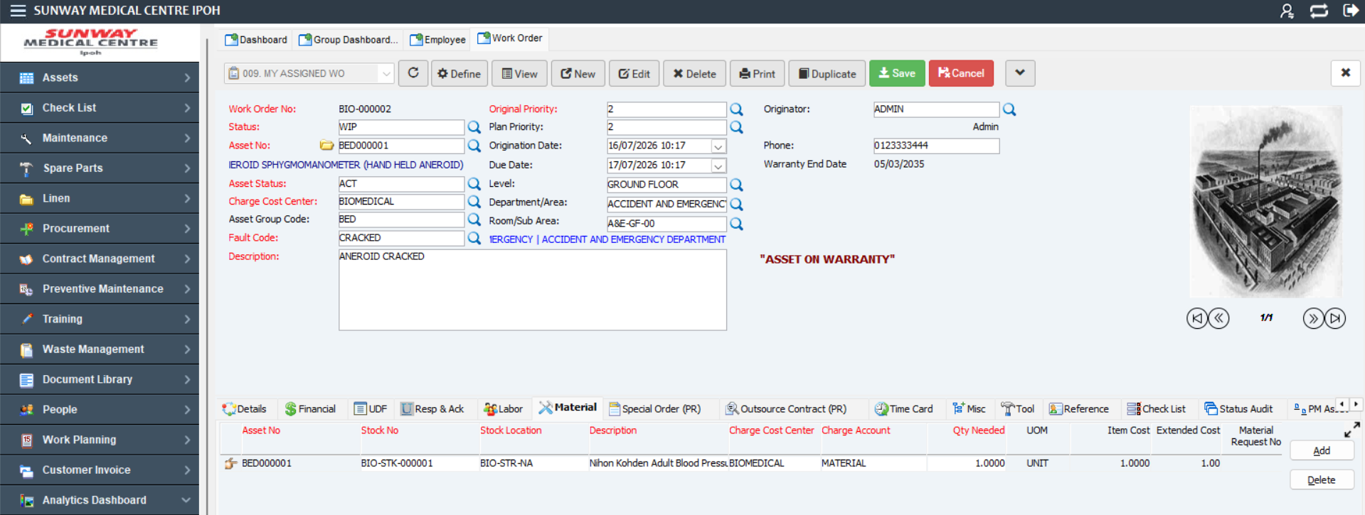
14.7 Click
14.6 Click

Double click in the “Stock No” field, and Stock Type window will pop up.

14.8 Double Click

Double clicked on “Part Master” and choose the required parts from the list.
(Note: This step is for the parts that not attached to the “Asset Number”. For parts that already attached to “Asset Number” please choose “Spare Part”)

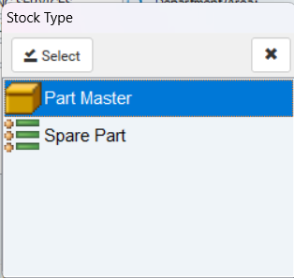
14.9 Double click

Key-in the required quantity in the “Qty Needed” field

Click on “Save” button, and Message Box will pop up.
(Note: To add another material, repeat step 14.7 until 14.12).

14.11 Click
14.10 Key-in Quantity

Click on “Yes” button, and Message Box with Material Request No will pop up.

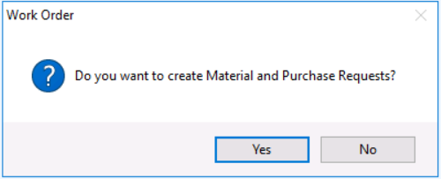
14.12 Click

Click on “OK” button to close the Message Box, and User will redirect back to table view.
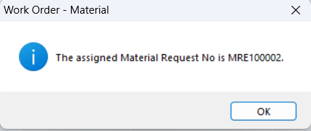
14.13 Click

Mobile Work Order– Planning for Material

Tap on “Work Order” on User Menu to expand.

Tap on “My Work Order” to view user assigned Work Order.

Tap to view the work order.

15.2 Tap
15.1 Tap
15.3 Tap

Click on “More” to expand the menu.

Click on “Material Request”.

15.5 Tap
15.4 Tap
14.4 Tap

Click “Add” to display the material line no.

Click “Stock No” to display the stock list.
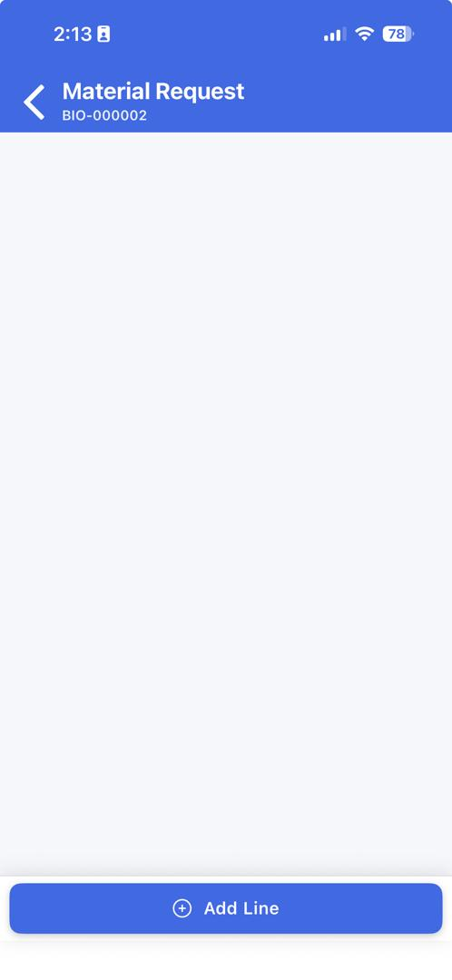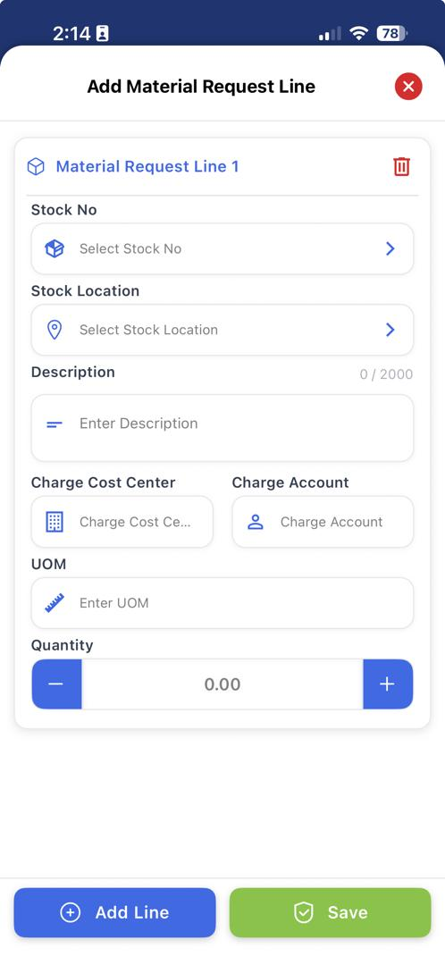
15.6 Tap
15.7 Tap

Click the stock that required for the work order.

Key-in the quantity that required.

Click “Save” to submit the material request.

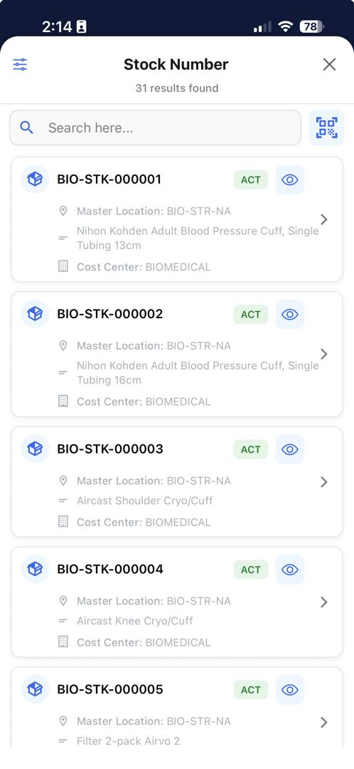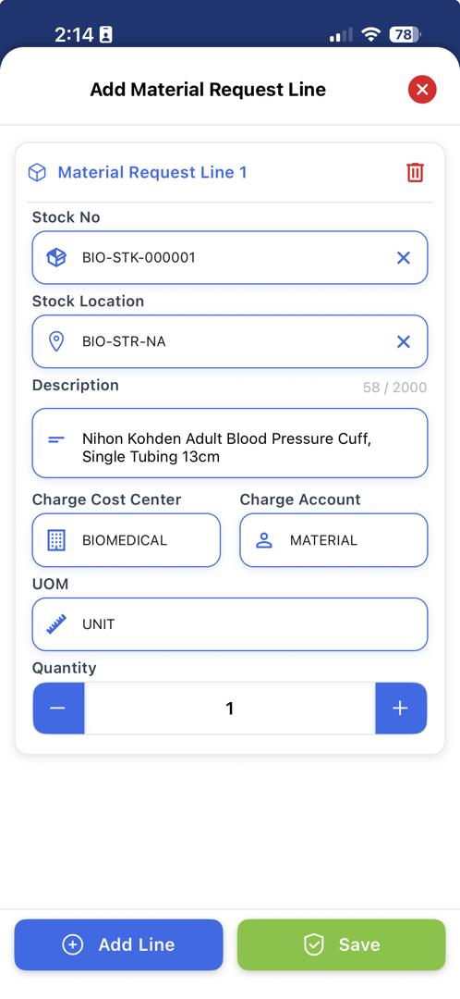
15.9 Key-in value
15.8 Tap
15.10 Tap

Click “Material Request” to display the material request status.
(Note: To add/request different material, please repeat step 15.6 and continue until 15.10)

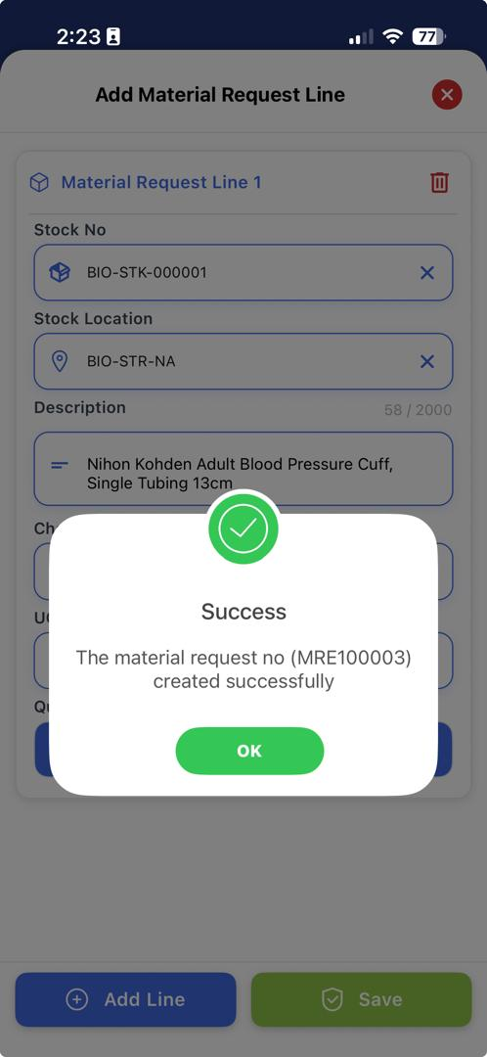
15.11 Tap

The material request status based on approval and the availability of the stock.
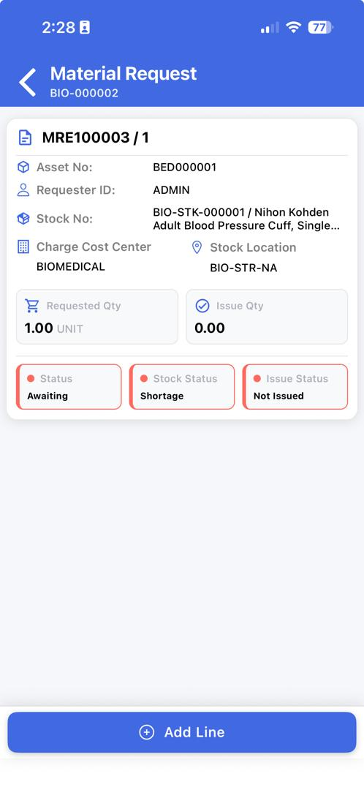
15.12 Tap

Work Order Module – Material Request Approval

Click on “Maintenance” on User Menu to expand.

Click on “Material Request Approval”, and table view will be open on the right.

Select “Awaiting My Approval (My Limit) to display material request that need to be approve based user approval limit.

Click on the material request that want to approve/disapprove by highlighting it

Click on the “Approve” button.
16.5 Click
16.3 Click
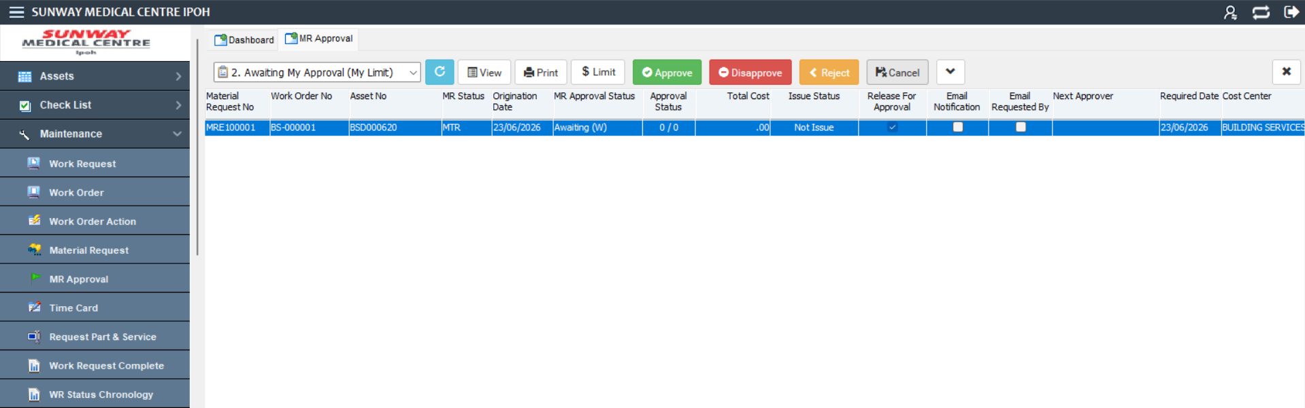
16.1 Click
16.2 Click
16.4 Click

Click the “Yes” button to approve the material request to complete the process.

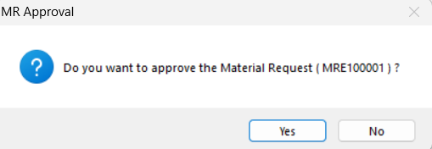
16.6 Click

Mobile Work Order Module – Material Request Approval

Click on “Maintenance” on User Menu to expand.

Click on “MR Approval”.

Click on material request that want to be approve.
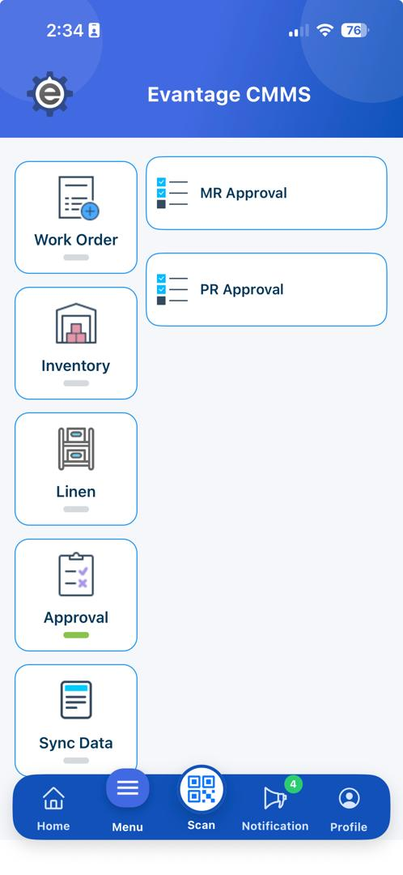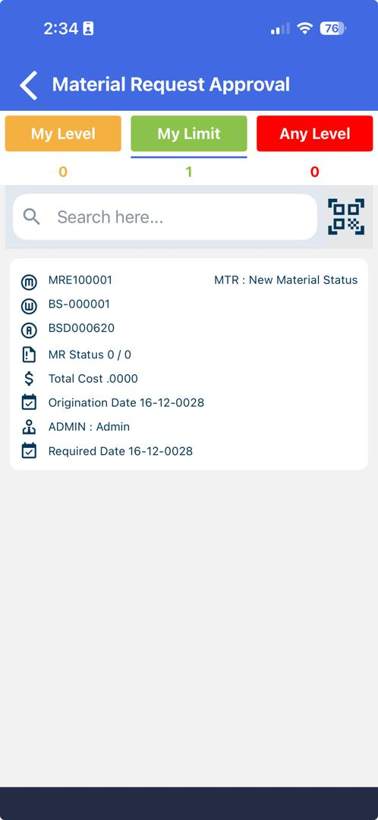
17.2 Tap
17.3 Tap
17.1 Tap

Tap on “Approve” button to approve

Enter remark and tap the “Save" button to complete the approval process.

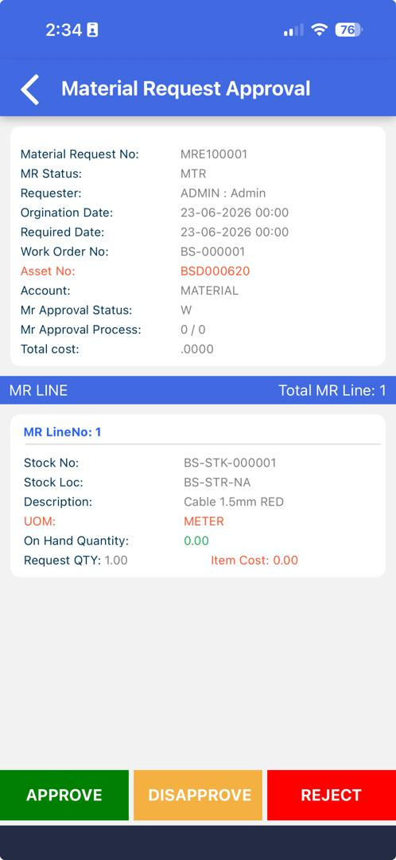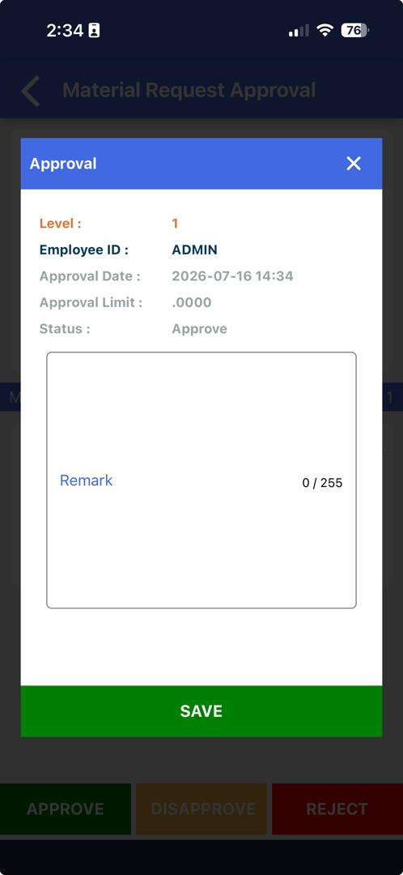
17.4 Tap
17.5 Insert

Inventory Module – Issue Transaction

Click on “Spare Parts” on User Menu to expand.

Click on “Issue Transaction”, and it will display on the right.

Click on “Material Request No” to select/search the material request no.

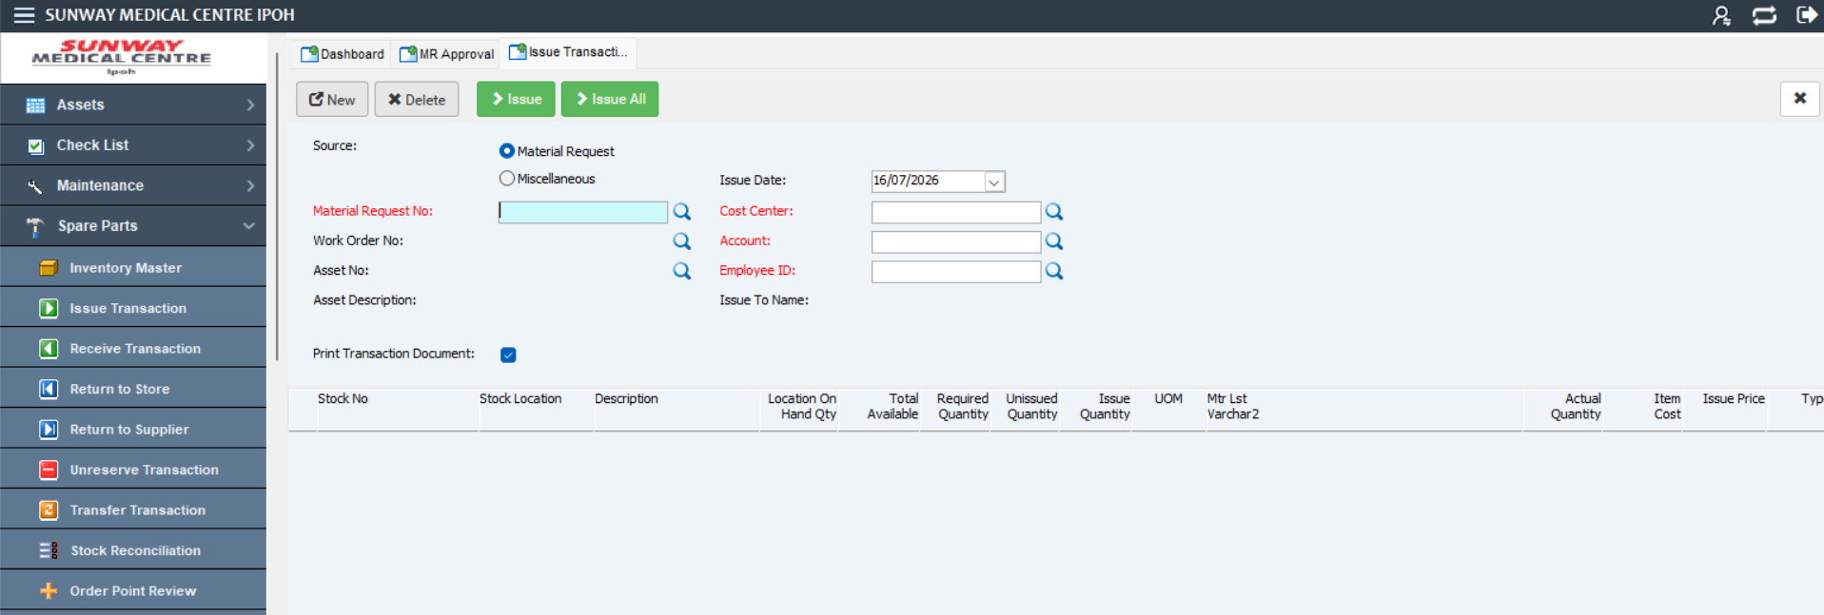
18.1 Click
18.2 Click
18.3 Click

Insert value on “Issue Quantity” based on the required quantity.

Select the employee that will pickup the stock.

Click the “Issue” button if the user want to issue 1 by 1 and “Issue All” button if want to issue all stock in the material request.

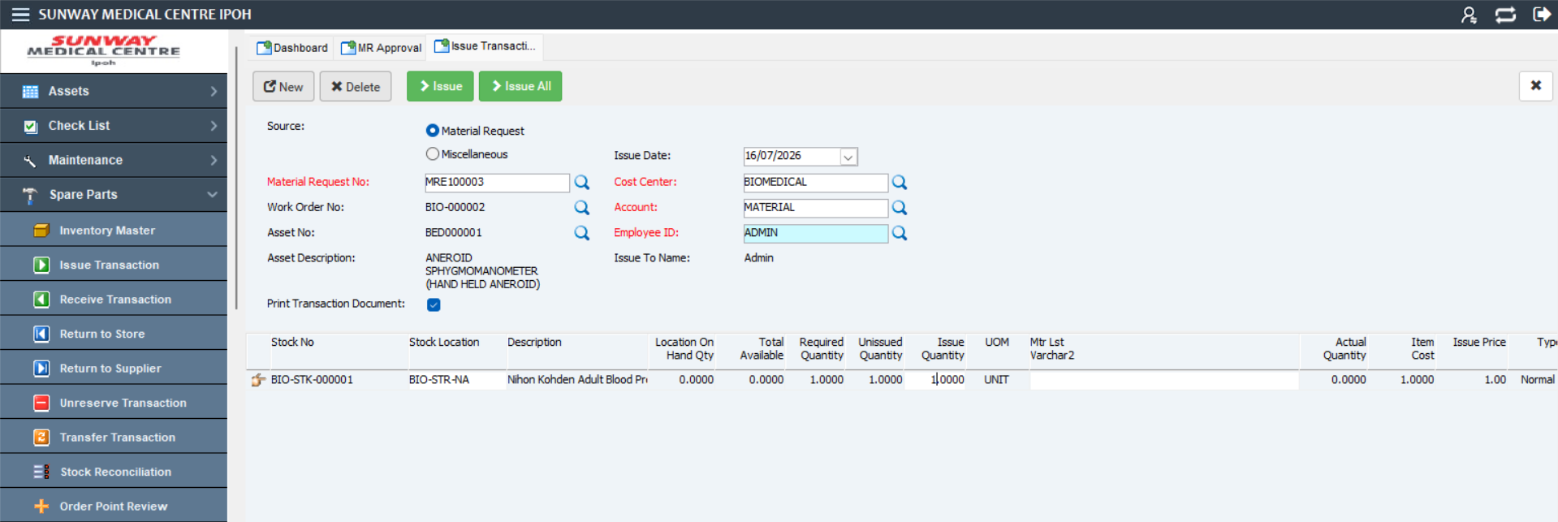
18.5 Click
18.4 Click
18.6 Click

Mobile Work Order Module – Issue Transaction

Tap on “Inventory” on User Menu to expand.

Tap on “Stock Issue” to direct to stock issue window.

Tap on “Material Request No”.
19.3 Tap
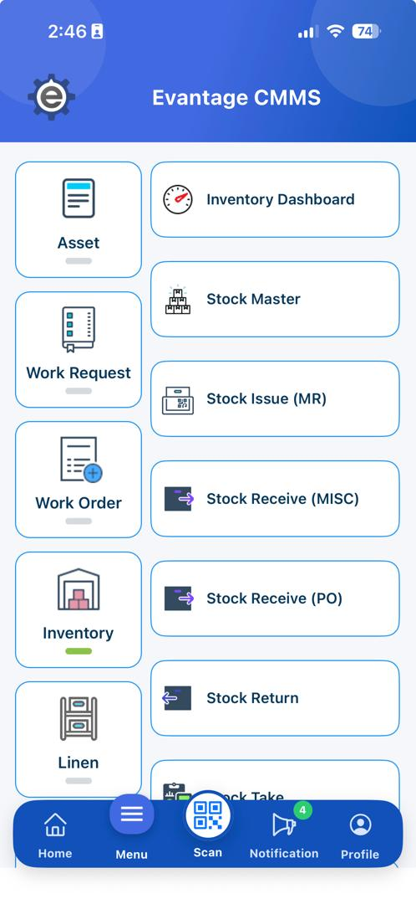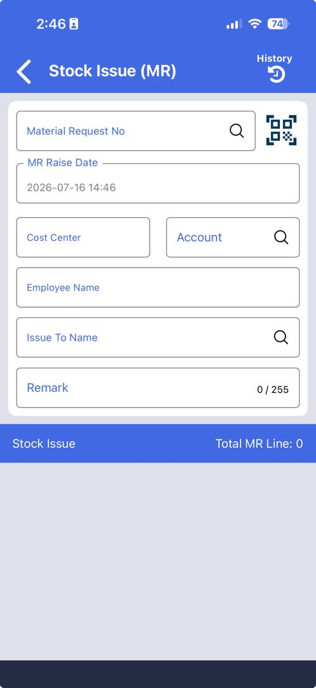
19.1 Tap
19.2 Tap

Tap on the selected material request and the information will be retrieved. User need to insert quantity that will be issued.

Tap on “Issue” button to complete the process.
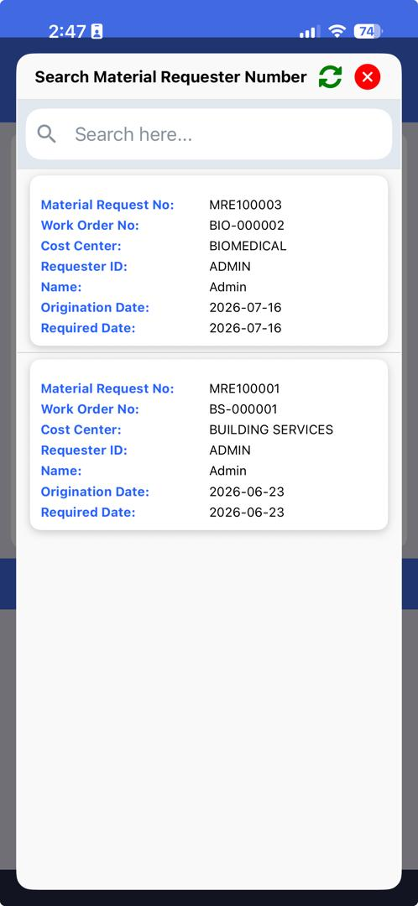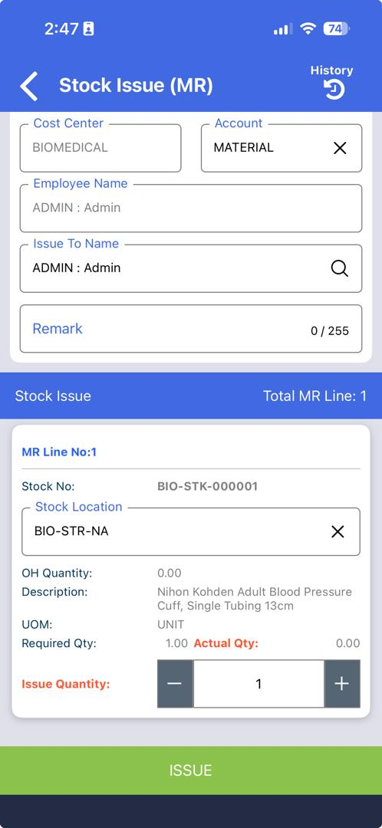
19.5 Tap
19.4 Tap
19.4 Tap

Inventory Module –Receive Misc Transaction

Click on “Spare Parts” on User Menu to expand.

Click on “Receive Transaction”.
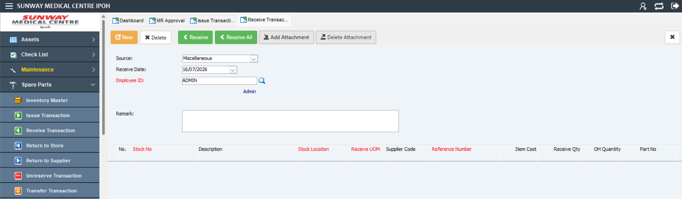
20.1 Click
20.2 Click

Insert below information in the column based on the value:
Field | Value | Have Master File?
Source | Miscellaneous
Remark | Item received | No
Stock Location | BIO-STR-NA | YES

Click the Receive button to receive the item or user also can click Receive All button if multiple line of item to be receive in single transaction.
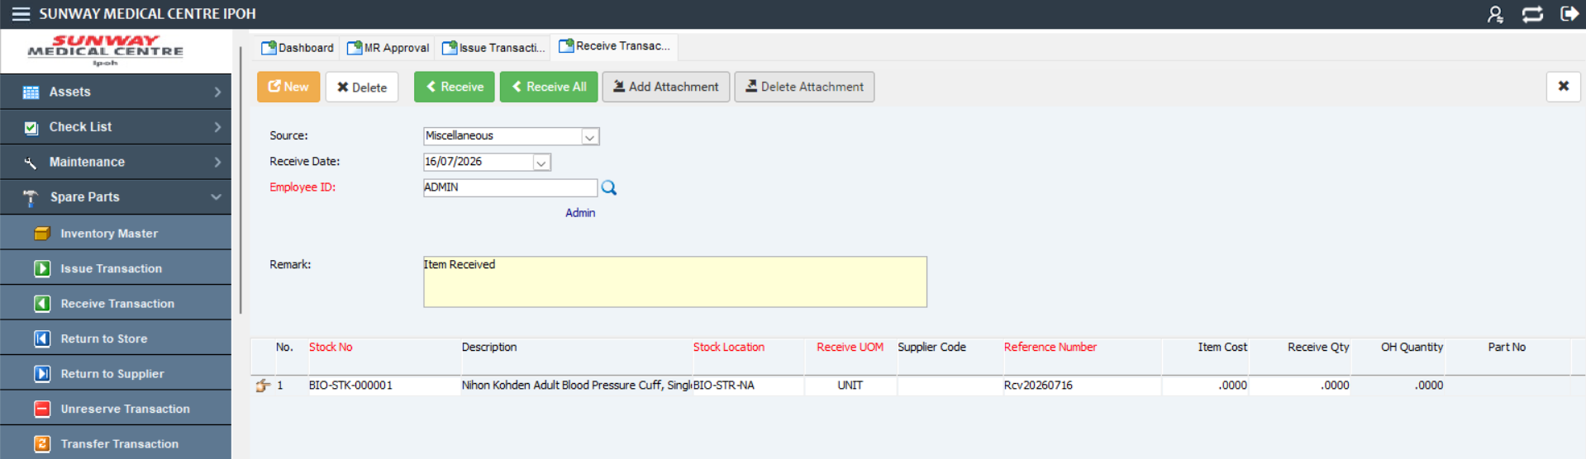
20.3 Click
20.4 Click

Mobile Work Order Module – Acknowledge Work Order

Click on “Work Order” on User Menu to expand.

Click on “My Work Order”, and work order assigned to the technician view will be open on the right.

Search or select the work order to be change to complete.
21.2 Tap
21.1 Tap
21.3 Tap

Click on “More” to expand the menu.

Click on “Acknowledge”.

21.5 Tap
21.4 Tap

Insert below information in the column based on the value:
Field | Value | Have Master File?
Acknowledge By | Alex Yung | No
Acknowledge ID | 1111 | No
Contact | 1234 | No

Tap Add Signature and obtain the requestor's signature.

Tap Confirm button to save the signature.

Tap Save button to save the Acknowledgement.

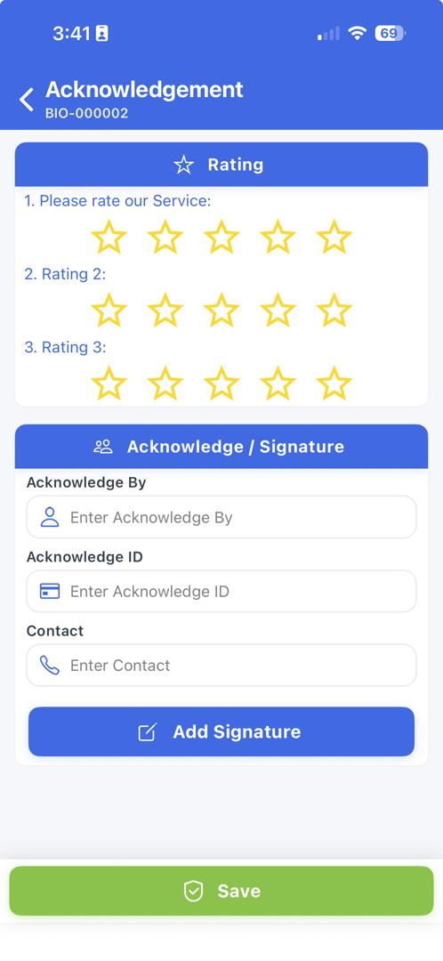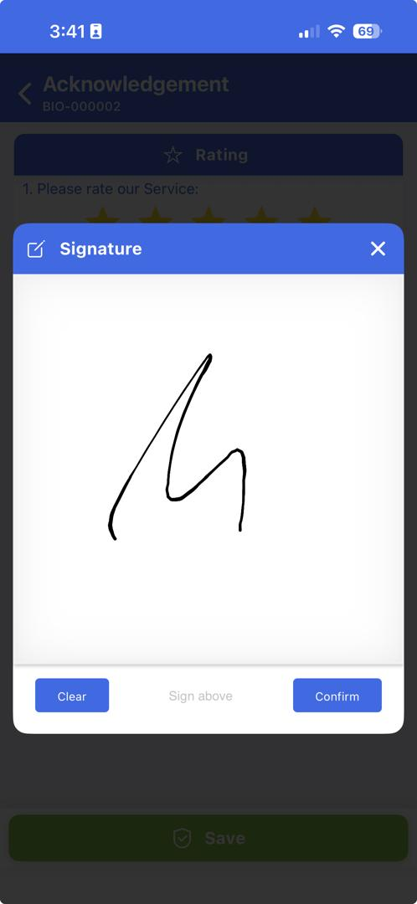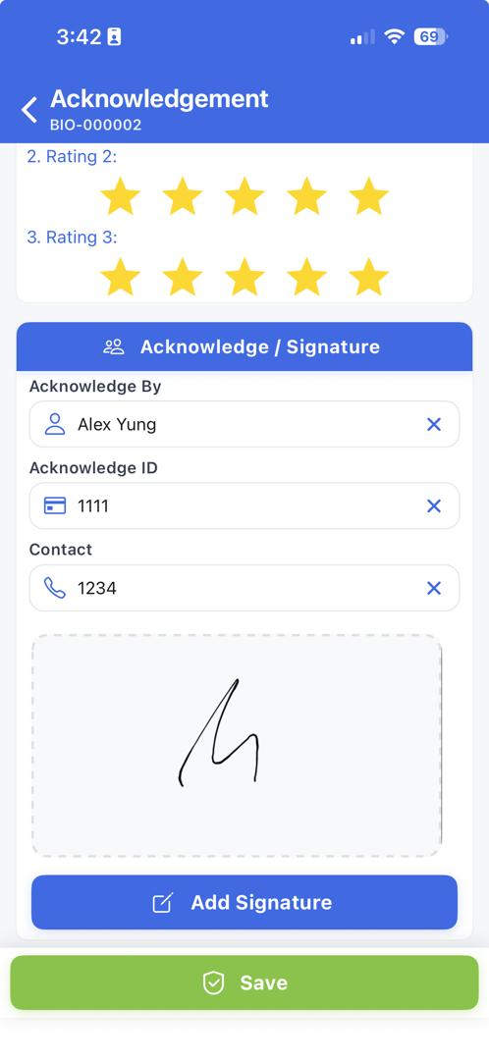
21.8 Tap
21.8 Tap
21.6 Select/Insert
21.7 Tap

Work Order Module –Complete Work Order

Navigate to the dashboard.

Click on “My Work Order”, and Work Order table view will be open on the right.

You can also select pre-set Define Query “009 MY ASSIGNED WO”, and table view will be refreshed.
22.2 Click

Select by highlighting the work order.

Click on “Additional Action (∨)” button, and a dropdown menu will display.
22.5 Select
22.4 Select
22.6 Select

Click the “Complete WO” button.
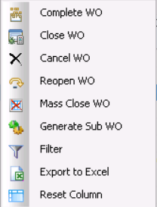

Insert below information in the column based on the value:
Field | Value | Have Master File?
Corrective Action | Change to new equipment | No
Action Code | CHANGE | YES

Click the “Save” button to complete the work order.
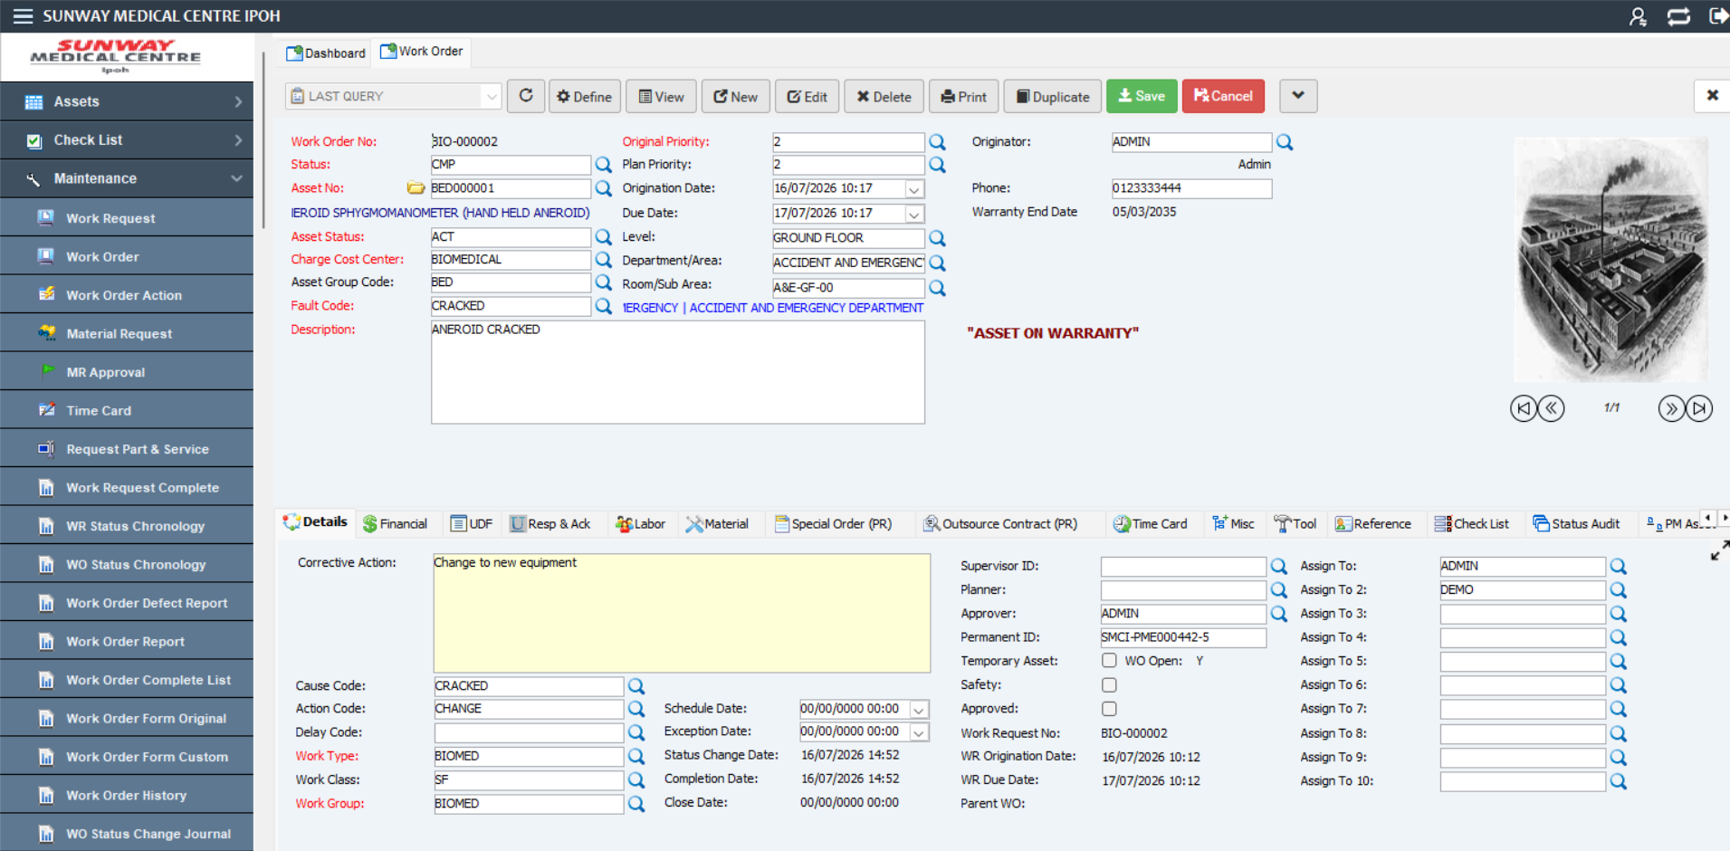
22.8 Select
22.7 Select

Mobile Work Order Module –Complete Work Order

Click on “Work Order” on User Menu to expand.

Click on “My Work Order”, and work order assigned to the technician view will be open on the right.

Search or select the work order to be change to complete.
23.2 Tap
23.1 Tap
23.3 Tap

Click on “More” to expand the menu.

Click on “WO Completion”.

23.5 Tap
23.4 Tap

Insert below information in the column based on the value:
Field | Value | Have Master File?
Cause Code | Cracked | YES
Action Code | To Change | YES
Corrective Action | Change to new equipment | No

Insert below information in the column based on the value:

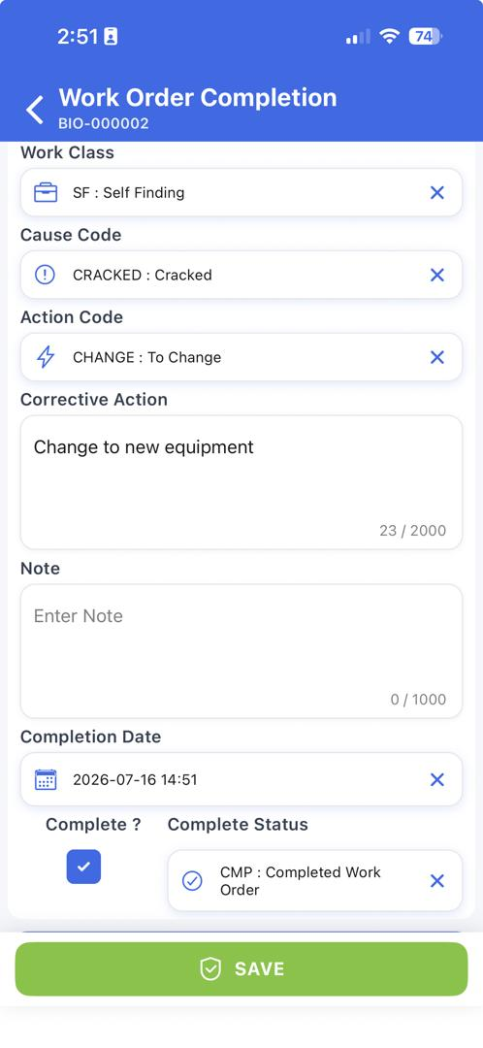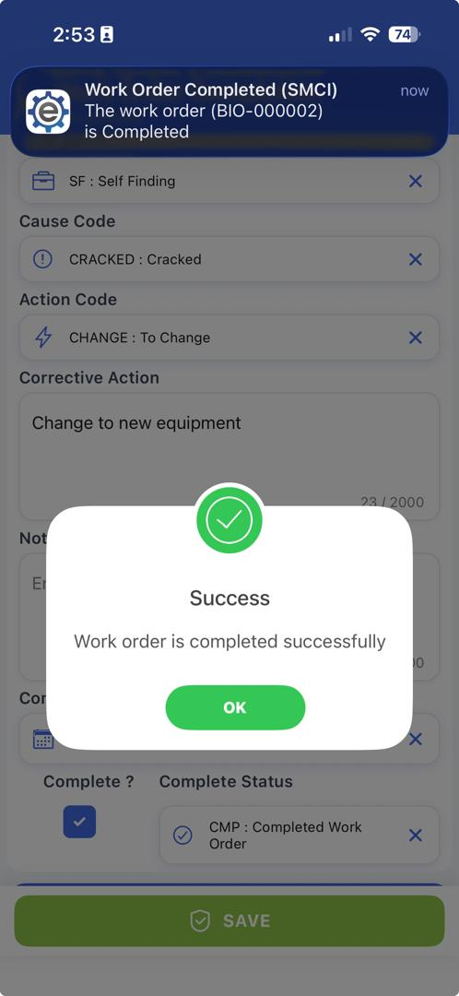
23.7 Tap
23.6 Select/Insert

Work Order Module – Close Work Order
(Note: Once the Work Order had been updated in the system, Person in charged need to verify & close the Work Order)

Click on “Maintenance” on User Menu to expand.

Click on “Work Order”, and Work Order table view will be open on the right.

Select pre-set Define Query “013. PENDING TECH CLOSED”, and table view will be refreshed.
(Note: The pre-set query could be change from time to time, please refer to system admin for assist).
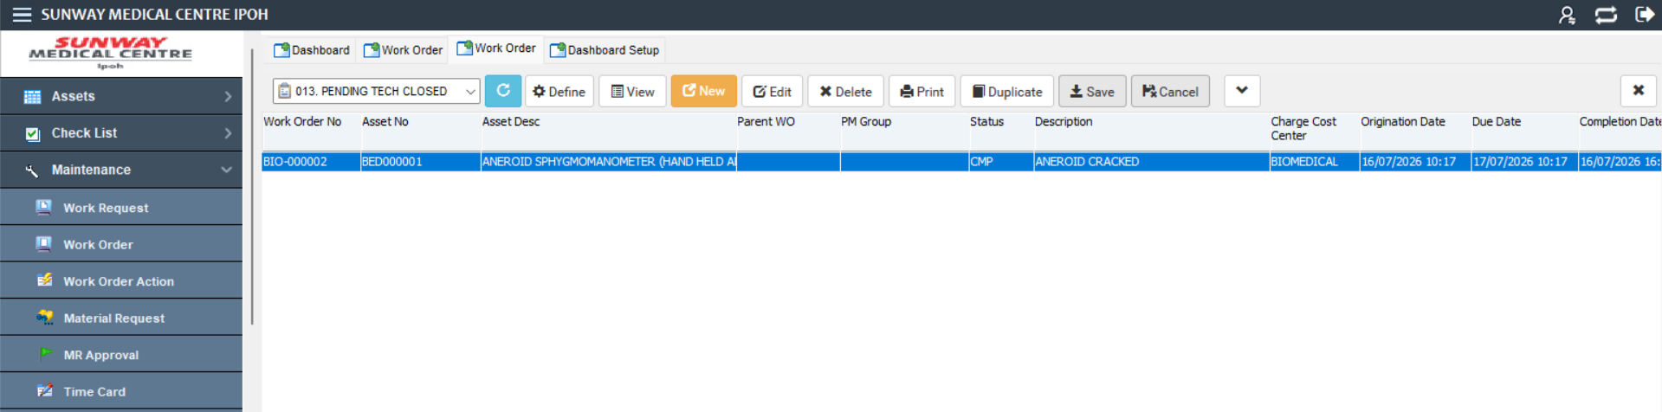
24.3 Select
4
24.1 Click

User also can click “Supervisor To Close” from the dashboard to close completed work order.
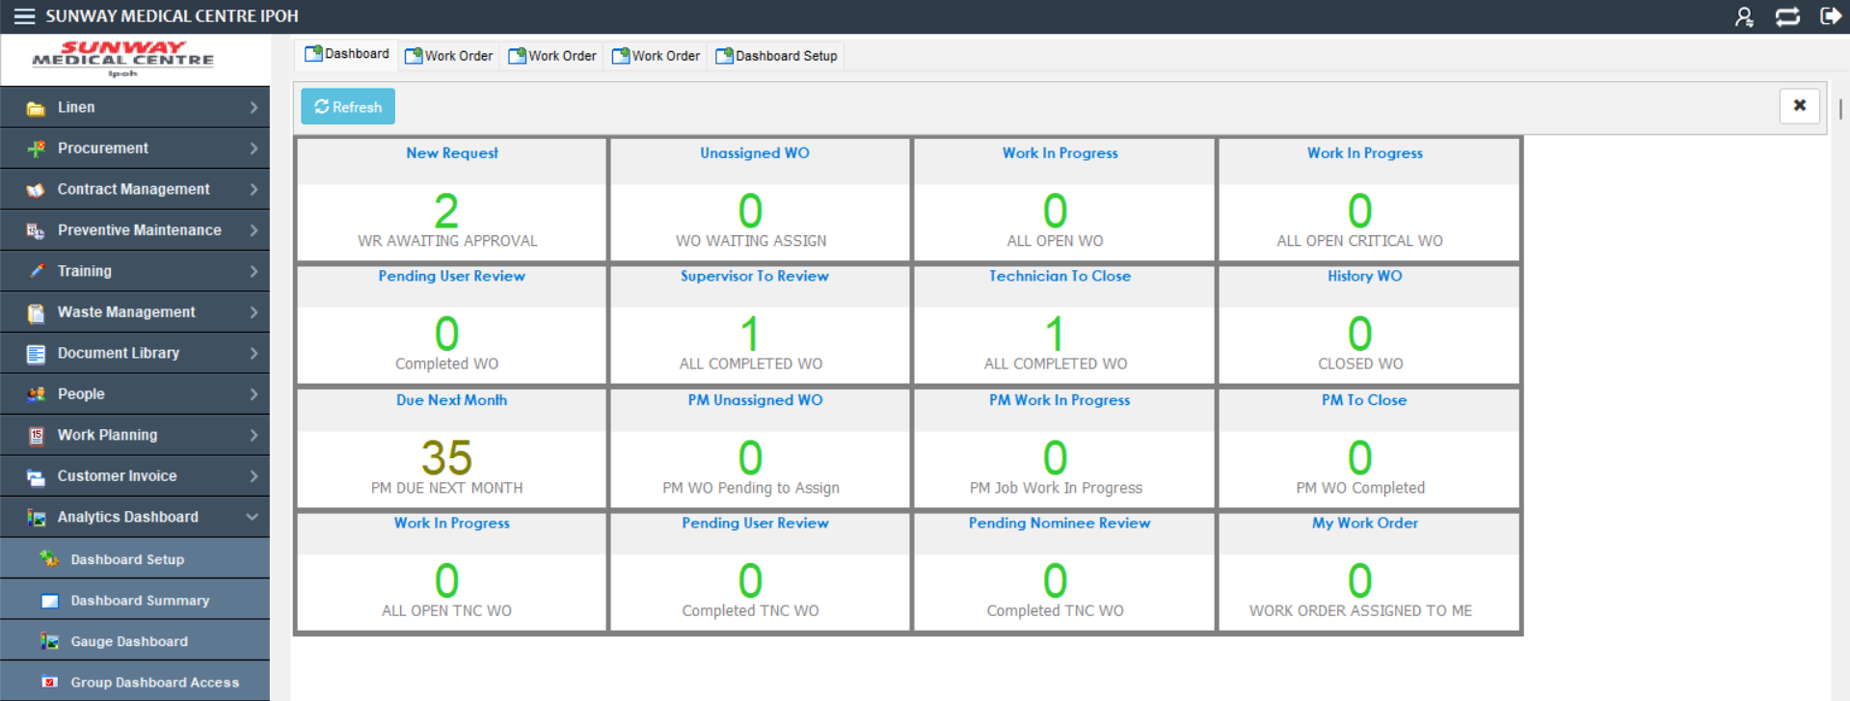
24.4 Click

Select record.

Click on “Additional Action” button, and Additional Action list will list down.
24.6 Click
24.5 Select

Select “Close WO”, and Close WO window will be open.
24.7 Select
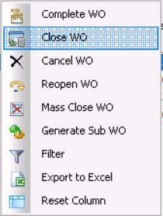

Select / Key in Work Order Completion information.
(**The value will automatically be inserted based on the time click the ‘Close Work Order’ button)

Field | Value | Have Master File?
Close Date | 16/07/2026 16:18 | No

Click on “Save” button, and User will be redirect back to table view.
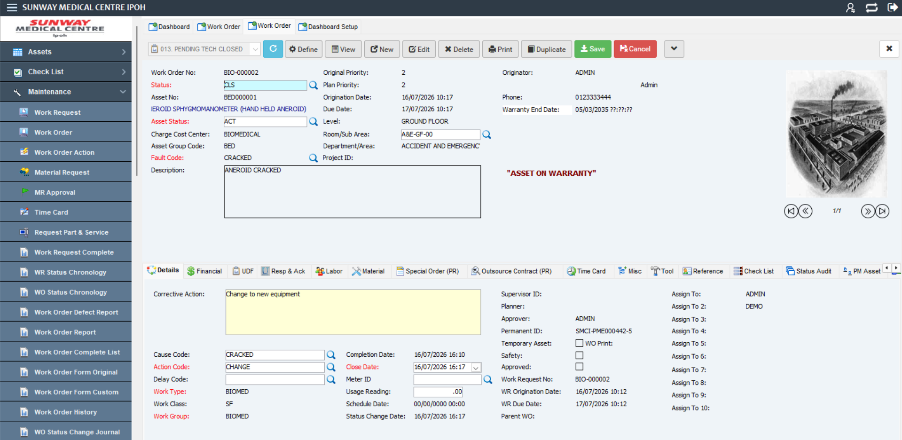
24.9 Click
24.8 Select / Key in

Mobile Work Order Module –Complete Work Order

Click on “Work Order” on User Menu to expand.

Click on “My Work Order”, and work order assigned to the technician view will be open on the right.

Search or select the work order to be change to close.
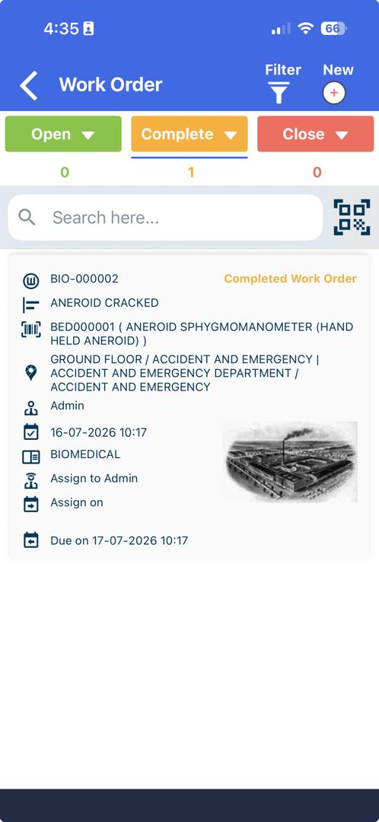
25.2 Tap
25.1 Tap
25.3 Tap

Click on “More” to expand the menu.

Click on “WO Close”.

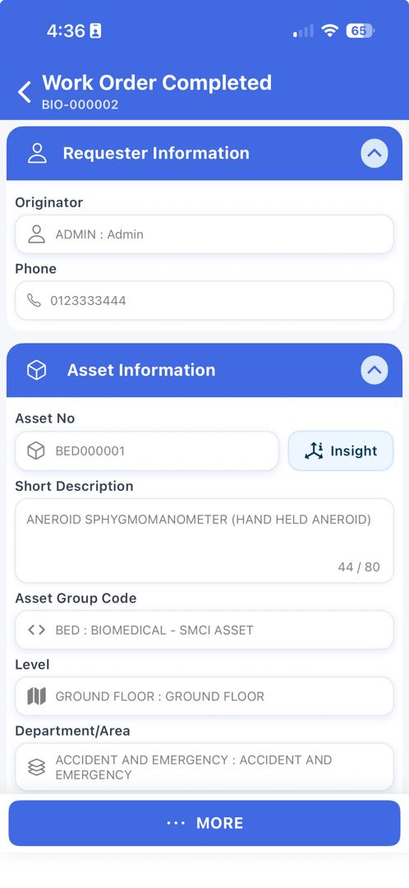
25.5 Tap
25.4 Tap

Tick “Close ?” checkbox.

Tap the “Save” button to close the work order.

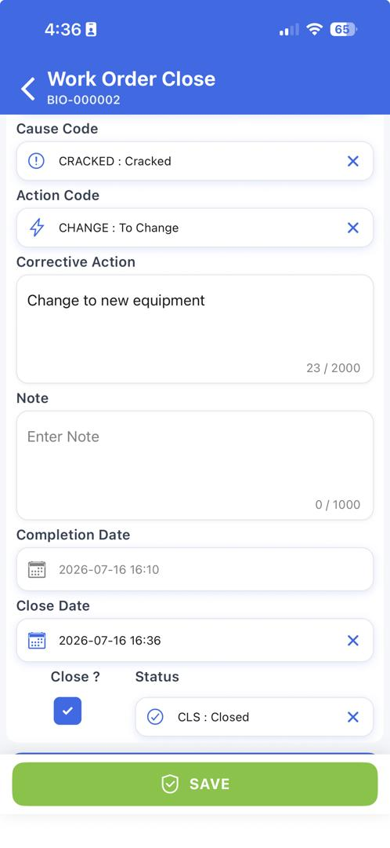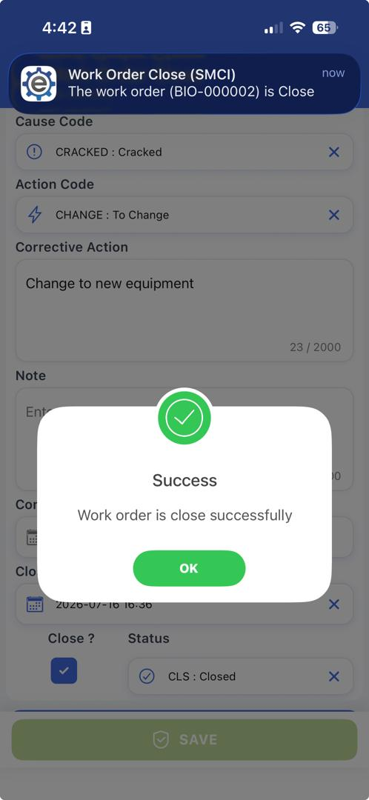
25.7 Tap

PPM Master Module –Create Preventive Maintenance

Click on “PPM Master” on User Menu to expand.

Click on “Preventive Maintenance”, and will be display on the right.

Click on the “New” button.
26.3 Click
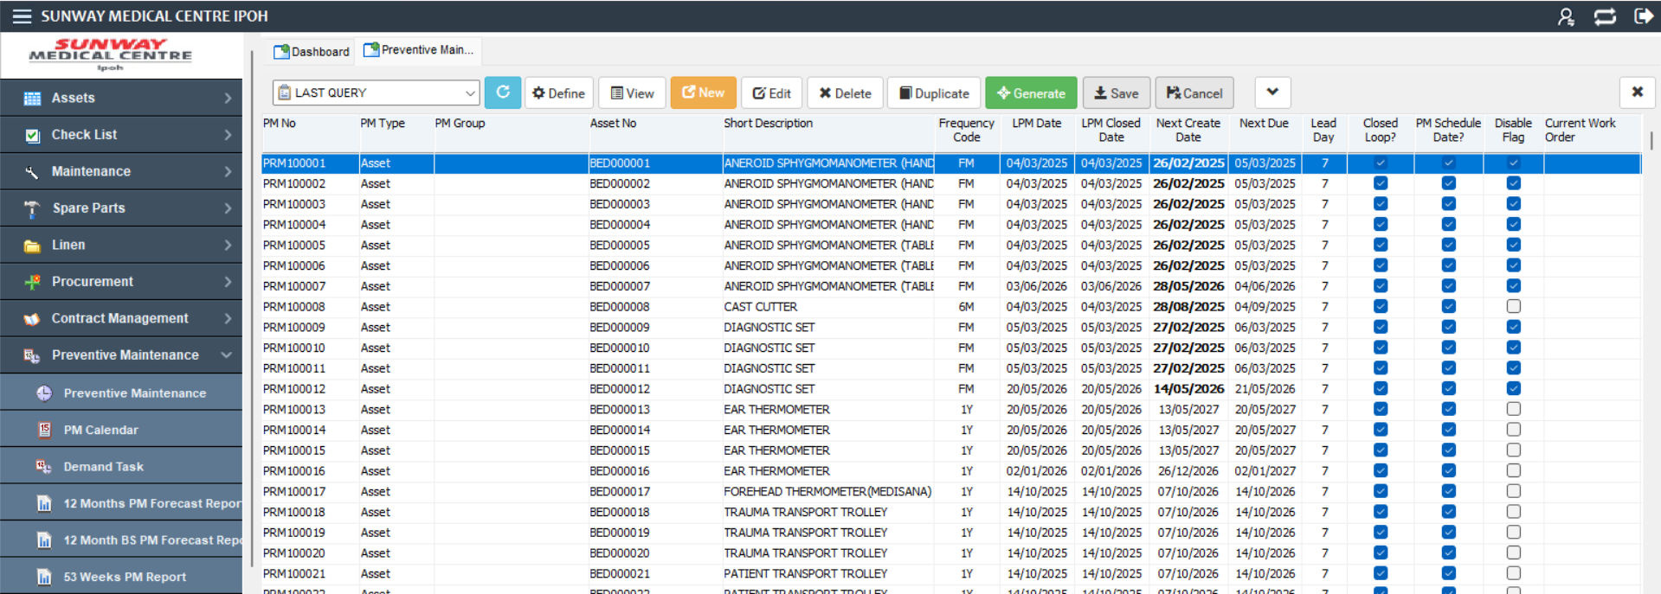
26.2 Click
26.1 Click

Select / Key in Work Order Completion information:
Field | Value | Have Master File?
Asset No | BEDS000001 | YES
Frequency | 6M | YES
Fault Code | PM | YES
Description | PPM FOR DEFIB | No
Cause Code | PM | YES
Action Code | INSPECTION | YES
Work Type | PM | YES
Work Category | IN-HOUSE | YES
Department/Sub Area | CHEMOTHERAPY DAY WARD | YES

Click the “Save” button to complete PPM registration process.
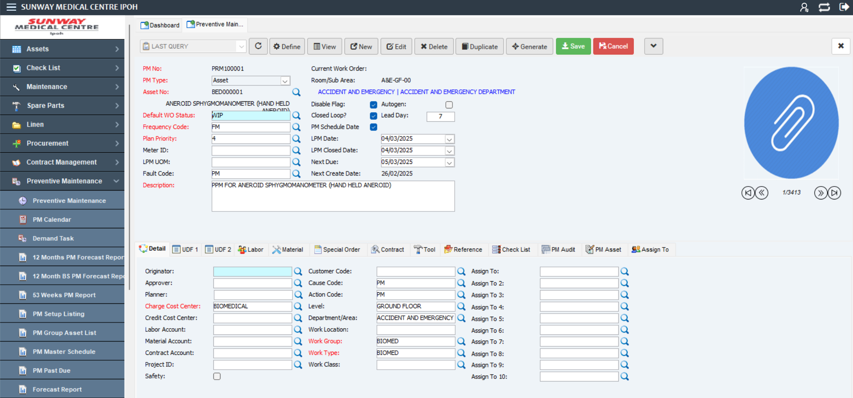
26.5 Click

The preventive maintenance will be automatically assigned with preventive order no.

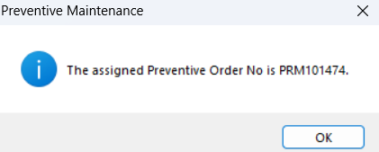

PPM Master Module –PM Generate

Click on “PPM Master” on User Menu to expand.

Click on “Preventive Maintenance” and PPM Master table view will be display on the right.

Click on “Define” button.
(Note: User also may use the Pre-Define Query to search and filter the Preventive Maintenance)

27.2 Click
27.1 Click
27.3 Click

Fill up by using the following detail to find the PM that need to be generate and click “Retrieve”.
Field | Value | Have Master File?
Field Name | PM No | No
Operator | like | No
Value | PRM100001 | YES

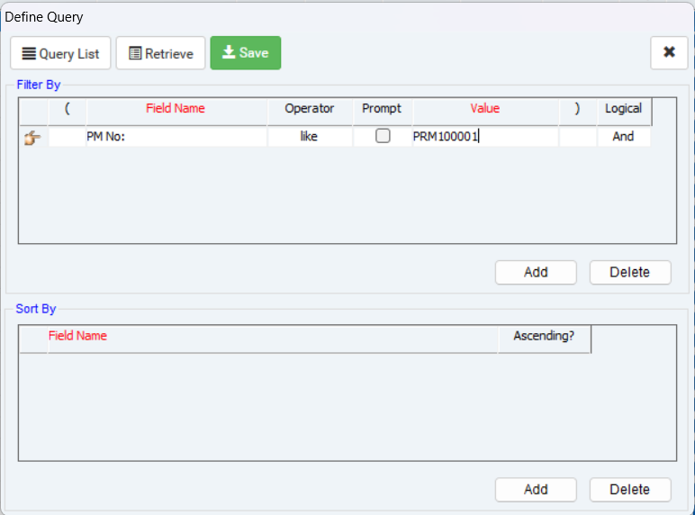
27.4 Click

Click on the “Generate” button”
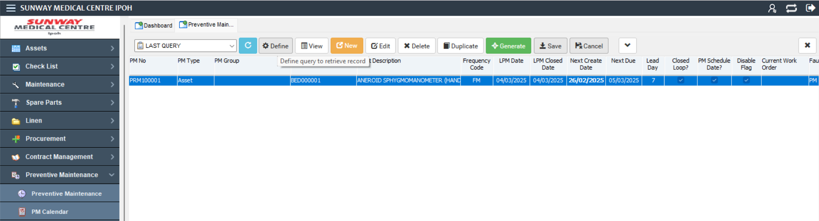
27.5 Click

Select generate PM for 1 selected record list and Click on the “Generate” button”.

Preventive work order successfully create and work order no will be automatically assigned.

Click on X to back to Preventive Maintenance table view list.

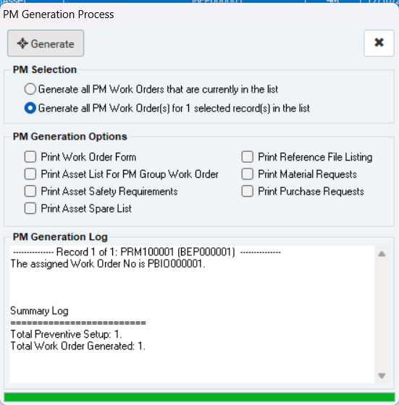
27.7 Click
27.8 Click
27.6 Click

Contract Module – Create New Contract

Click on “Contract Management” on User Menu to expand.

Click on “PO Contract” and the table view will be display

Click on the “New” and the contract registration module will be display

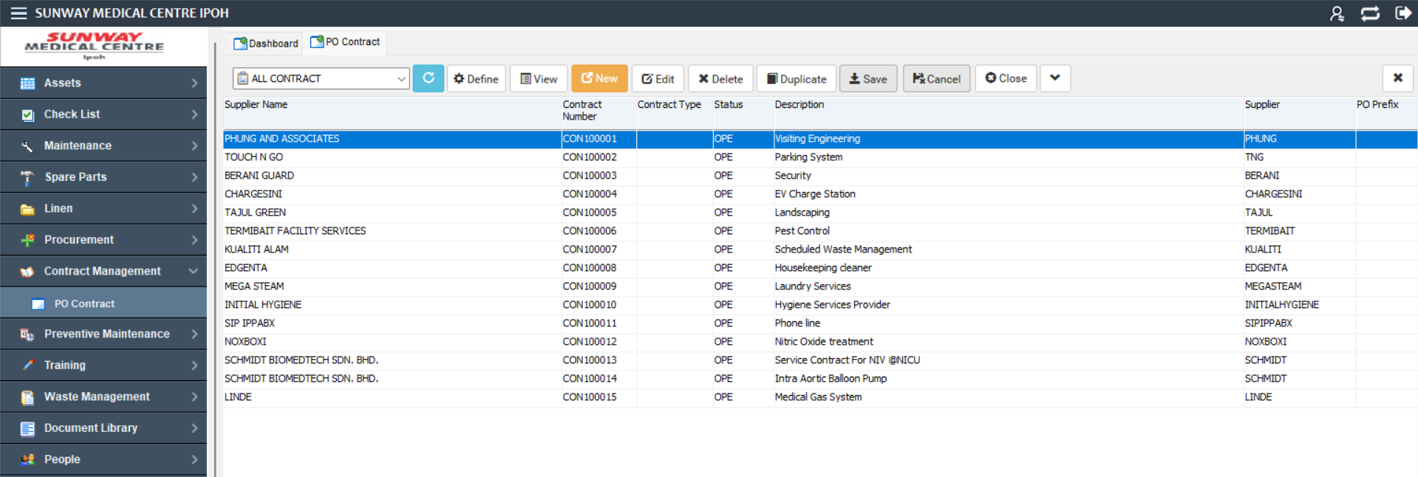
28.3 Click
28.2 Click
28.1 Click

Fill in all the column by using below details:

Field | Value | Have Master File?
Department | BIOMED | YES
Status | OPE | YES
Contract Date | 27/07/2026 | No
Expired Date | 27/07/2027 | No
Description | Visiting Engineering | No
Total Cost | 10000 | No

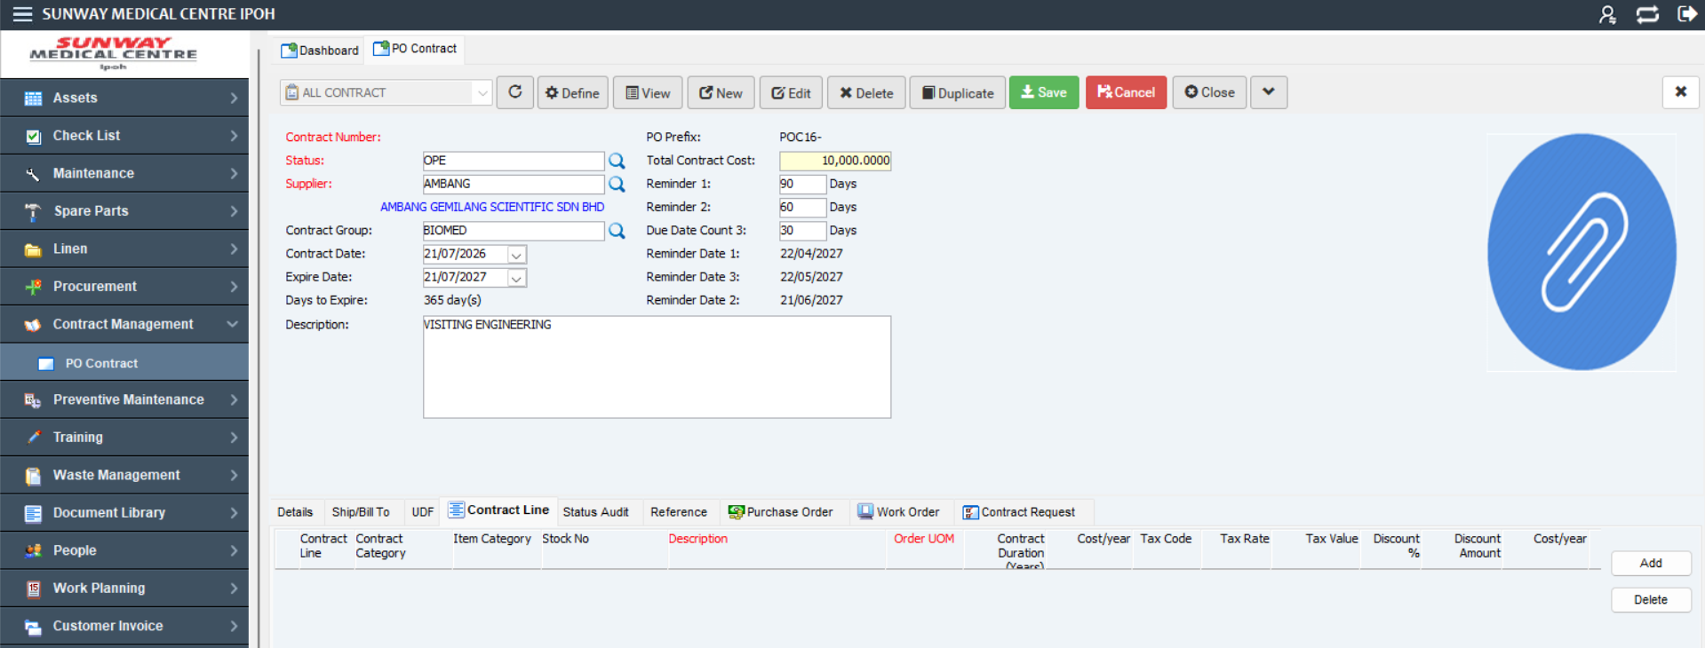
28.4 Insert

Click Save button to save the contract
28.5 Save

