

Deduction Demerit Report
Indicator 4 & 5
March 2026

Computerized Asset Management System
(CAMS)

DOCUMENT CONTROL

GENERAL INFORMATION

Document Name | : | Deduction Demerit Report
System | : | Computerized Asset Management System (CAMS)
Customer Name | : | TRIplc Medical Sdn Bhd
Site Name | : | Hospital UiTM Al-Sultan Abdullah, Puncak Alam
Prepared By | : | Ezwan Sani (Evantage Solutions Sdn Bhd)
Creation Date | : | 27th April 2026
Version | : | 1.0

Version Control
Revision  No | Revision  Date | By | Description
1.0 | 27/04/2026 | Ezwan | Deduction demerit report for Indicator 4 & 5, March 2026

Dear Khadijah,

Screencut below show the PPM Forecast Manager that we used in generating the planning for FEMS’s PPM in 2026

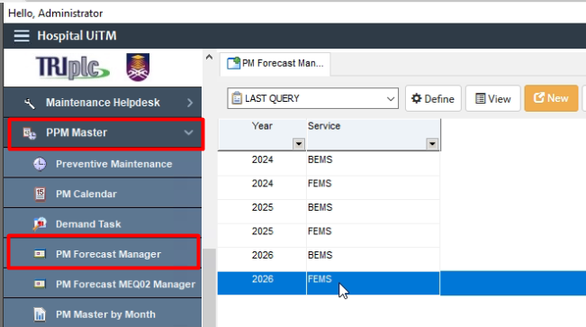
Figure 1: PPM Forecast Manager

From this Forecast Manager, all FEMS’s asset that status active is listed here together with the planning of its PPM for 2026.
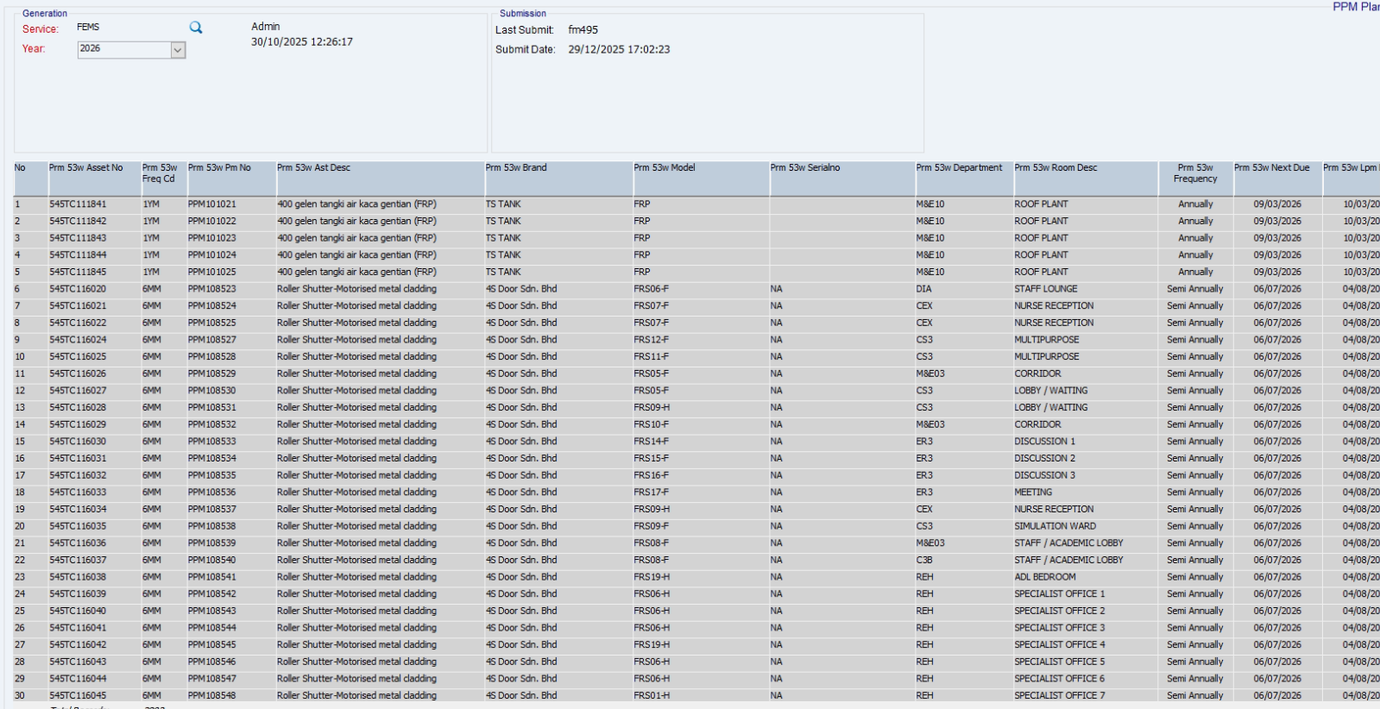
Figure 2: Forecast Manager Asset List

The plotted “X” shows on what weeks should the PPM will be scheduled for that particular asset.
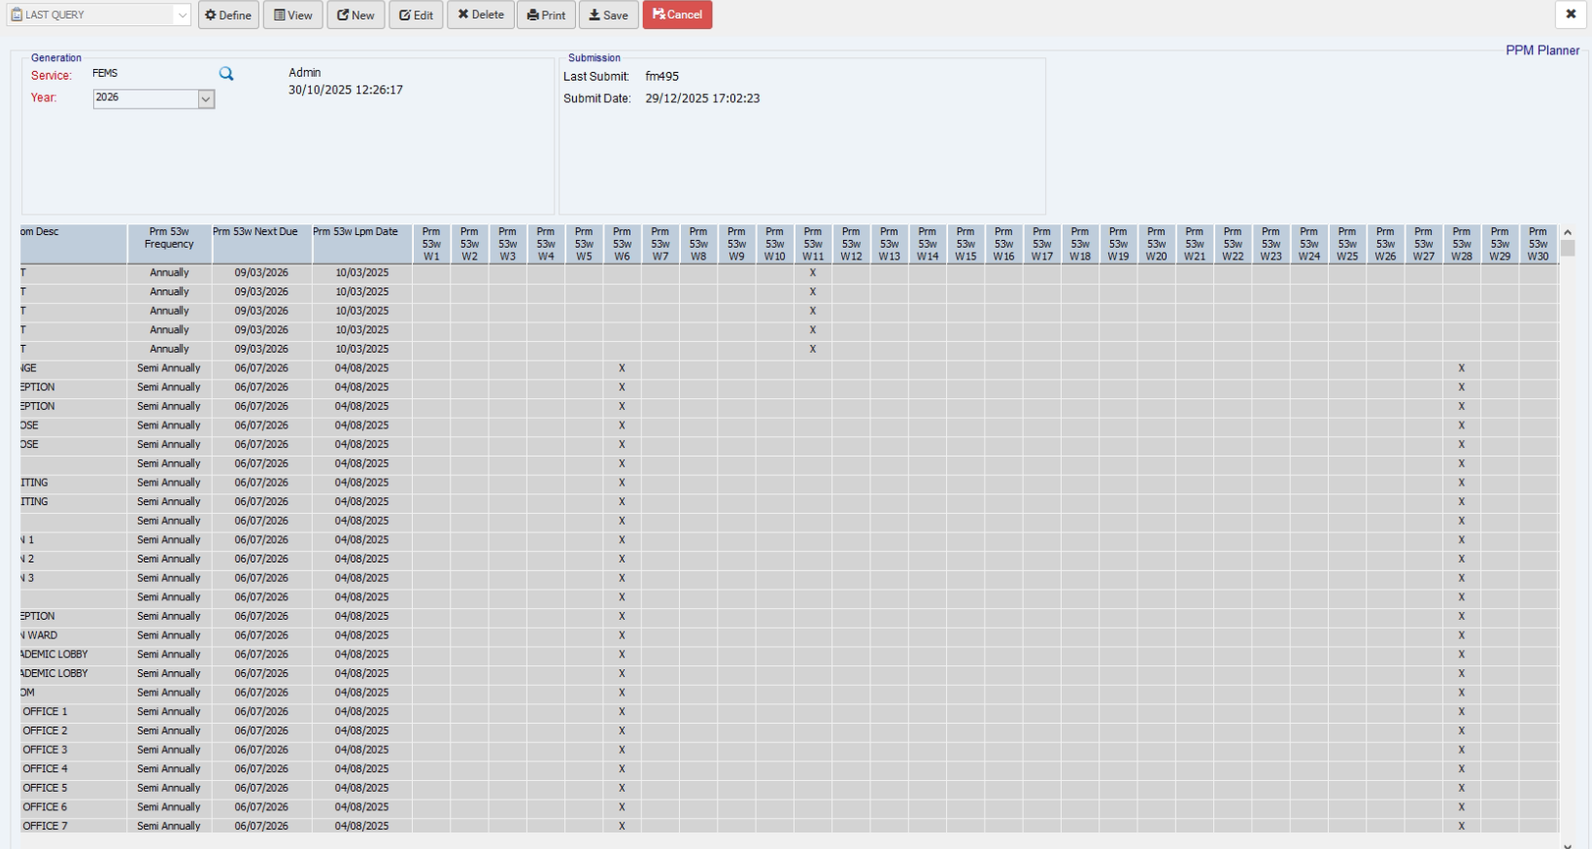
Figure 3: Forecast Date - Plotted by Week Number

As of my email sent on Mon 27/04/2026 10:25 AM, I have mentioned that the root cause of the issue is that the missing forecast date (Figure 3) upon generating the Forecast Manager.

In the screencut below, we can see that the Next Due date is not matched the Due Date in planning table.
For our case in March 2026, one of the lines in the planning table shown as in figure below is missing that lead to this issue.
Taking PPM106048 for example, the Next Due date and the Due Date column in planning table did not match which lead to the system detecting that the PPM is not generated for that month.
