https://evantage.ddns.net:80/React_Asset_code_scan/dashboard.php
(** Please copy the source code and develop in another folder, do not using the original source code to amend)
New Link : https://evantage.ddns.net:80/AssetQR
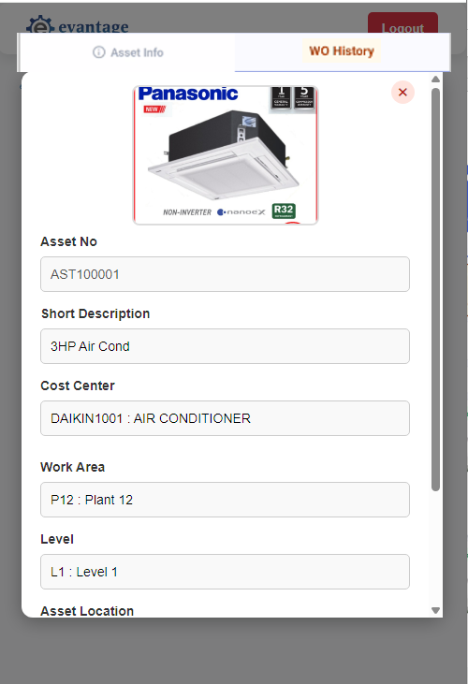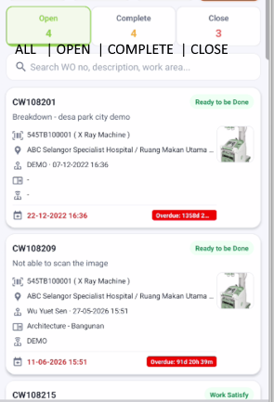
- Enhanced the current asset QR scan to view the work order information.
- Maximize the page view in mobile view
- Adding the WO history tab > when click, it will open the work order page at bottom
- Open WO Page with 4 Dashboard, by Default, it will show All.
- Show the Work Order information like the design in mobile apps, you may get the API/Column mapping with Sekhar as first mock-up.
- Able to Click and Open the Work Order Details Screen (** Please plan for this design, the list view to click and open the work order details screen, it will be in next phase and not immediate)

